|  |  |  |
| --- | --- | --- |
| Analysis of surgical techniques and procedures using a motion capture system | | |
| D:\00_Teaching\00_2016-17_Teaching\04_FYP_BEng\CMSProxyImage.png | | |
| BEng/MEng Biomedical Engineering | | |
| Faculty of Health, Education and Life Sciences | | |
| School of Health Sciences | | |
|  | | |
|  | Student Name: | Bill M Mutisya |
|  | Student Number: | S17132235 |
|  | Submission Date: | may / 2020 |
|  | Supervisors: | Dr. Bisola |
| Dissertation submitted to Birmingham City University in partial fulfilment of the requirements for the degree of Bachelor of Engineering | | |

Abstract

An analysis of surgeons performing different procedures and techniques was undertaken using a motion capture system. A simulation was created to replicate this. Markers detecting motion were placed on the participant and instruments in order to examine them doing the procedure. This is then compared to the professional surgeons’ technique. If it does not correlate the participant readjust and repeat the procedure until an improvement is seen. The results showed the participant improved but did not perfect technique.

Acknowledgements

All thanks to Eddie. This would have been impossible without him.

[1 Introduction 1](#_Toc510538190)

[1.1 Background and problem definition 1](#_Toc510538191)

[1.2 Scope of the project 1](#_Toc510538192)

[1.3 Rationale 1](#_Toc510538193)

[1.4 Aim(s) and objectives 1](#_Toc510538194)

[2 Review of Existing Knowledge 5](#_Toc510538200)

Surgical training

Modern day use of simulations, motion analysis systems

Posture analysis of surgeons during surgery

[3 Methodology 6](#_Toc510538201)

[4 Design Development 7](#_Toc510538202)

[5 Results and Analysis 1](#_Toc510538203)

[6 Discussion 2](#_Toc510538204)

[7 Conclusions 3](#_Toc510538205)

[8 Recommendations 4](#_Toc510538206)

[9 References 5](#_Toc510538207)

[10 Appendix 6](#_Toc510538208)

List of Figures

[Figure 1 Anatomical Manikin 8](#_Toc39602885)

[Figure 2 (Dr. Khan 2017) 8](#_Toc39602886)

[Figure 3 Dr Choudhary performing an opening incision at 90-degrees (2014) 9](#_Toc39602887)

[Figure 4. The angle is between b-c . The incision the length is a-c is covered in 10 seconds (Dr. Ausaf Ahmed Khan 2017) 9](#_Toc39602888)

[Figure 5 fingertip grip (Dr. Ausaf Ahmed Khan ,2017) 10](#_Toc39602889)

[Figure 6 (Themes, U.F.O. 2016) 10](#_Toc39602890)

[Figure 7 Finger positions (Dr. Ausaf Ahmed Khan 2017) 10](#_Toc39602891)

[Figure 8 two holding methods pronated hand(right) and supinated forearm(Dr. Khan 2017) 11](#_Toc39602892)

[Figure 9 Callibration 12](#_Toc39602893)

[Figure 13 Position of markers on hand and angle created 14](#_Toc39602894)

[Figure 14 Position of markers on arm and angle created 14](#_Toc39602895)

[Figure15 Markers on medical device 15](#_Toc39602896)

[Figure 16 The movements are done on an anatomically accurate manikin 16](#_Toc39602897)

[Figure 17 This data is displayed on graph showing degrees and displacement 16](#_Toc39602898)

[Figure 18 showing the graphs to the left and the live protocol to the right 17](#_Toc39602899)

[Figure 19 Finger positions (Khan, 2017) 18](#_Toc39602900)

[Figure 20 Dr Choudhary performing an opening incision at 90-degrees (2014) 19](#_Toc39602901)

[Figure 21Figure 9. The angle is between b-c . The incision the length is a-c (Dr. Ausaf Ahmed Khan 2017) 20](#_Toc39602902)

[Figure 22 fingertip grip (Dr. Ausaf Ahmed Khan ,2017) 20](#_Toc39602903)

[Figure 23the angle of incision (Themes, U.F.O. 2016) 21](#_Toc39602904)

[Figure 24 two holding methods pronated hand(right) and supinated forearm(Dr. Ausaf Ahmed Khan, 2017) 22](#_Toc39602905)

[Figure 25 Marker are placed on the three points of the scissors to measure the cutting angles as shown below 22](#_Toc39602906)

[Figure 26 vector calculation settings 2](#_Toc39602907)

[Figure 27 The vector angles 25](#_Toc39602908)

[Figure 28 tweezers 47](#_Toc39602909)

[Figure 29 Whiteboard with augmented reality manikin 47](#_Toc39602910)

[Figure 30 Physical manikin 48](#_Toc39602911)

[Figure 31 “The motion is at a right angle to the scalpel pressure”. (Khan ,2017) 49](#_Toc39602912)

[Figure 32 Markers are also placed on the arm and the hand to measure the movement angles. The goal is to reduce shaking for a steady arm. 51](#_Toc39602913)

[Figure 33 The needle and position of markers (B. Braun Surgical S.A., n.d.) 51](#_Toc39602914)

Nomenclature (Note: below are examples, delete and append as appropriate)

Roman Symbols

Symbol Description Unit

d diameter $mm$

l length $mm$

n engine speed $rpm$

V voltage $V$

Greek Symbols

Symbol Description Unit

$ϵ$ strain -

$γ$ isentropic exponent -

$σ$ stress $N⋅m^{-2}$

Indices

Symbol Description

1, 2…n number in increasing order

in initial

out output

# Introduction

## Background and problem definition

Research into augmented reality simulations led to the discovery of surgical simulations (Sutherland et al. 2006). The popularity of surgical simulations with junior doctors and surgeons is because of inadequate access to cadavers and patients needed to practice making incisions and other various medical procedures in simulated scenarios. (Badash et al., 2016) This has made them essential in all medical schools. (Agha et al. ,2015)

A simulation was created which analysed and imitated surgical techniques. This will improve the speed at which medical students learn producing more competent, experienced surgeons which greatly benefits the NHS.

## Scope of the project

The project analysed various medical procedure and techniques which were then replicated by the participant. The participant could range from amateur to practising surgeons improving and fine-tuning techniques. This participant will also be cognizant of their own posture and the way they stand hence reducing any ergonomic challenges.

Non-scope

Ethics and data protection factors

* The researcher was the only participant.
* All medical equipment was sterilised
* No sharp blades where used.
* When doing the procedure, the handle of the scalpel was used. This prevents any ethical dilemmas.

## Rationale

Residents and junior doctors have limited access to cadavers and the patient needed to practice performing various medical manoeuvres/techniques in various scenarios. All this should be done while still maintaining good posture This has created a demand in simulations in medical schools.

The project will benefit

* The NHS and the educational field by speeding up the rate of learning first aid and how to deal with the various emergency procedure.
* It can also be used by residents, junior doctors, and practicing surgeons to fine-tune their skills without using patients as guinea pigs.
* It can also help the robots being developed to replicate surgery by offering a database that offers a detailed examination of surgeon movements and procedures. This further improves its applicability in various functions.
* It can be used in physiotherapy to help with recover hand-eye coordination by slowly retraining the muscles.

## Aim(s) and objectives

The aim is to collect data and analyse surgical technique and procedure in depth in order to replicate them using a motion capture system. The simulation created needs to able to train and improve participants' surgical skills.

Objectives

* Collect data on how to use medical instruments
* Collect data on how surgeons’ arm and body are positioned during the procedure.
* Analyse the data and using the motion capture system.
* Replicate the technique and procedure while still maintaining good posture.
* Repeat the procedure until it is identical to surgeons.

# Review of Existing Knowledge

**Surgical training**

“See One, Do One, Teach One” method taught by Kotsis (2013) states that teaching simple surgery can be quickly replicated by a student after a few viewings and observation of the procedure being done by a more experienced surgeon. Students are then expected to teach it to other students. This method has been criticized as being flawed because it leaves a lot to the unknown thus putting the patient at risk from things such as residents or junior doctors performing unnecessary or overly extensive surgery (Rogers, 2006). This also makes the student more likely to make mistakes owing to the fact observing does not translate to practical application.

An article by Kotsis (2013) also describes that “28 – 42%” of residents feel inadequately trained to safely perform various medical procedures such as central venous line placement alone for the first time.”

Sweeney (2012) offers a different approach. He states that they have been an increase in the amount of surgical knowledge and technical skills needed to be trained and yet they have been a decrease in time students spend on a surgical rotation. Educators’ solution to this massive challenge is to create realistic learning objectives for the student using new modalities such as simulations and more self-allocated practice time. This system can only work if the student showing initiative for self-learning. (appendix A)

Students self-learning in small groups need access to cadavers in order to carry out various studies and hone learned skills. This creates a higher demand for cadavers. Cadaveric training is expensive and not always practical. This results in fewer surgeons getting adequate access to them. (Sweeney, 2012).

Simulation-based training is currently the most used method of teaching (Papanikolaou, 2019). This modality enables the teaching of both technical skills and nontechnical skills in a safe, accurate representation of a real medical emergency in a non-threatening environment (Badash, 2016). This is the main inspiration for the project.

A detailed analysis of simulation proves that its use can be justified in three ways.

Pedagogical, ethical, and practical. (app sect A.1)

The biggest disadvantage of simulations is that they are not always able to completely re-create real-life situations/scenarios such as unexpected scenarios where the student is forced to adapt, compromise, and making a difficult decision in the heat of the moment.

**Modern-day use of simulations, motion analysis systems in the medical field**

The reasoning behind using the codamotion system for the project was because of its high speed and high-resolution active marker system that can provide smooth data at low latency (Vtvek Datta, 2001). Its biggest weakness is that the system does not have a software development kit allowing integration with the unity system. This was needed in order to produce a virtual reality simulation. It cannot collect adequate information at extremely high speed. This is due to the cameras not detecting the markers at high sample rates e.g. 500ms (app. section A.2)

**Posture analysis of surgeons during surgery**

The main ergonomic challenges during surgical procedures such as laparoscopic surgical procedure are the surgeon’s posture. They have been multiple reports of a high number of injuries which are all related to poor posture in surgeons. (Reddy, 2011)

The solution to this is lies in Pramod (2019) article which talks about the Alexander technique. This is a process of psychophysical re-education of the body.

(appendix section A.3)

# Methodology

In the simulation created the surgical procedure replicated are done on an anatomical manikin. This creates a safe environment to practise technique and various procedures. (appendix section B.1)

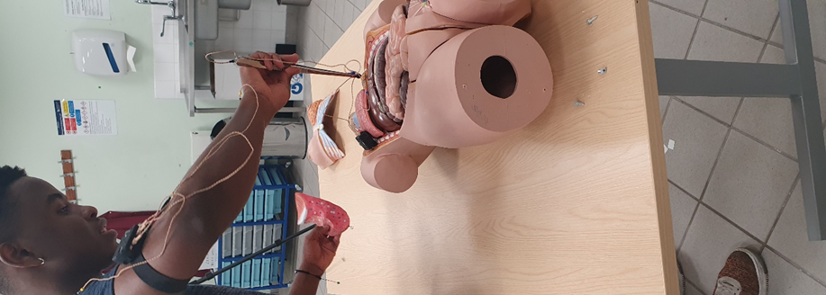

Figure Anatomical Manikin

The participant performs an incision which is then compared to how a trained surgeon or manufacture does it. If it does not match the participant re-adjusts themselves -according to the surgeon's advice- and tries to duplicate the procedure. These repeats are done multiple times to perfect and improve technique.

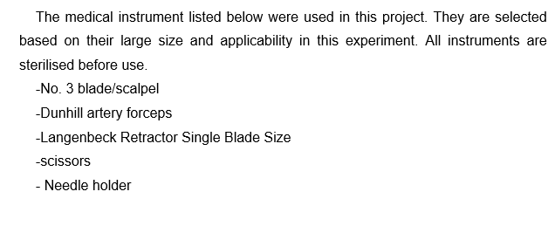 Multiple medical instruments were measured and analysed. The angles measured were the movement of the arms and the angle between the instrument and area of the incision. During all this ,the participant will have to be cognizant of their own posture.

**Procedures and Techniques chosen**

(appendix section B.2)

**1. First procedure replicated: Opening incision**

Opening surgical incisions are made to be as small and unobtrusive. This is done to facilitate safe and timely operating conditions. In order to make an accurate and precise opening incision, the scalpel is held at a 90° angle to the skin. (Choudhary, 2014). This is done to minimize bleeding.

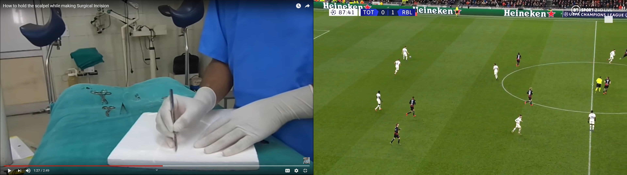

Figure Dr Choudhary performing an opening incision at 90-degrees (2014)

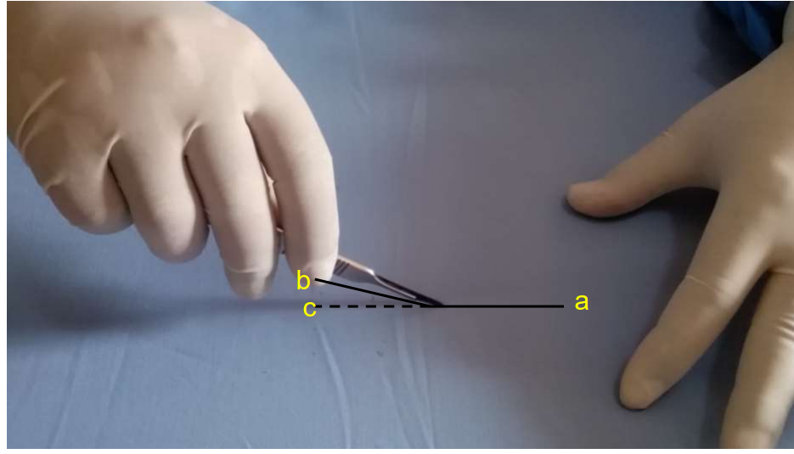

Figure . The angle is between b-c .

The incision the length is a-c is covered in 10 seconds at a steady velocity. This reduces error caused by rushing (Khan ,2017)

Note:

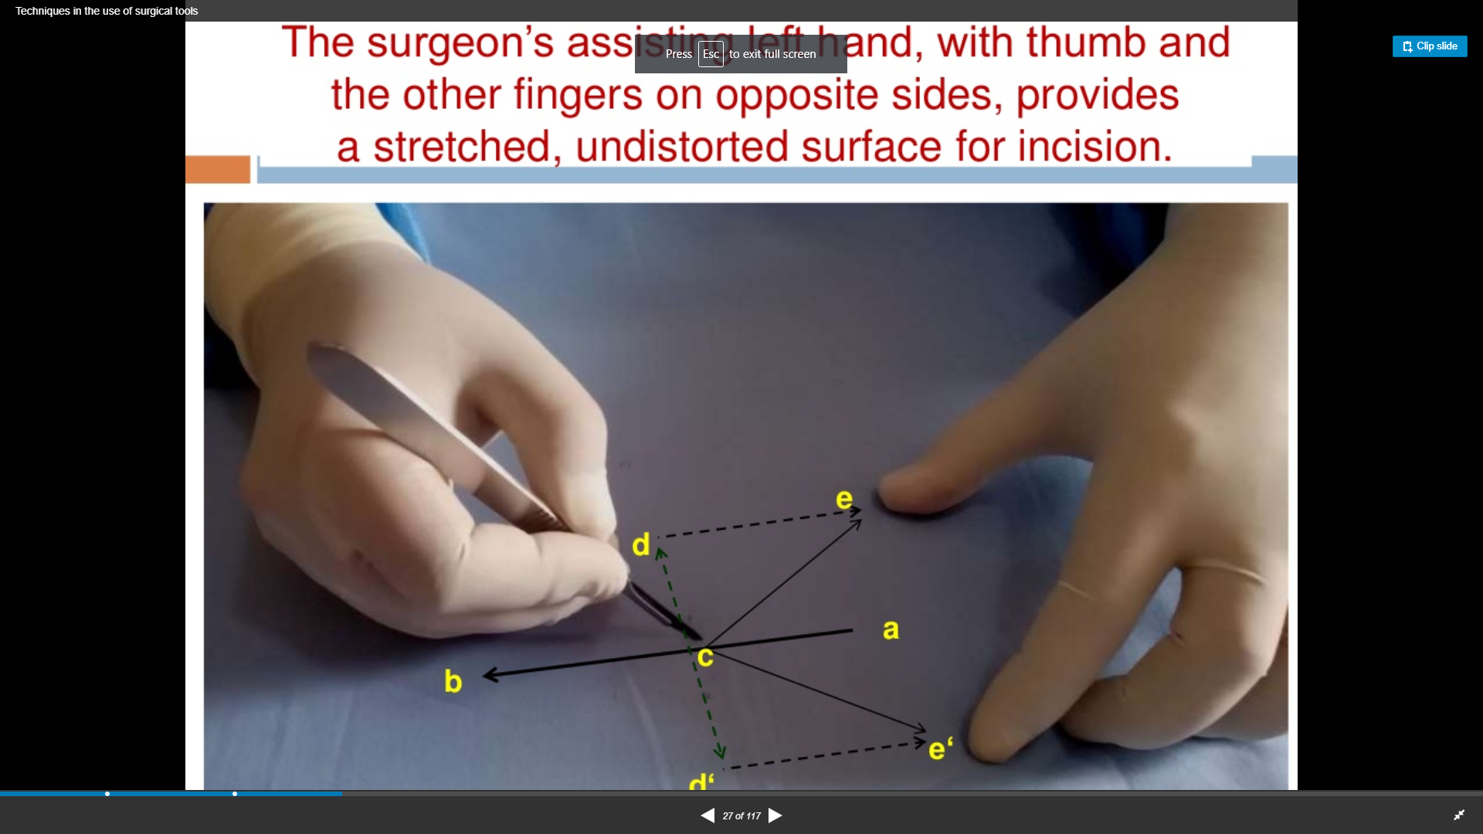

Figure Finger positions (Dr. Ausaf Ahmed Khan 2017)

During all incision, the fingers on the left hand should be placed opposite the right hand holding the scalpel. This is done to create a stretched undistorted surface. (Khan, 2017).

**2.Second technique replicated: Fingertip Grip**

The optimum incision (figure 9) for quick wound healing is when the blade is at a 0° to 45° angle on the skin(area of the incision). This is achieved using the fingertip grip(fig.10). In addition to the grip improving the accuracy of incision it also maximizes the blade edge contact with the skin for a long incision. This technique relies mostly on arm motion. (Khan, 2017)

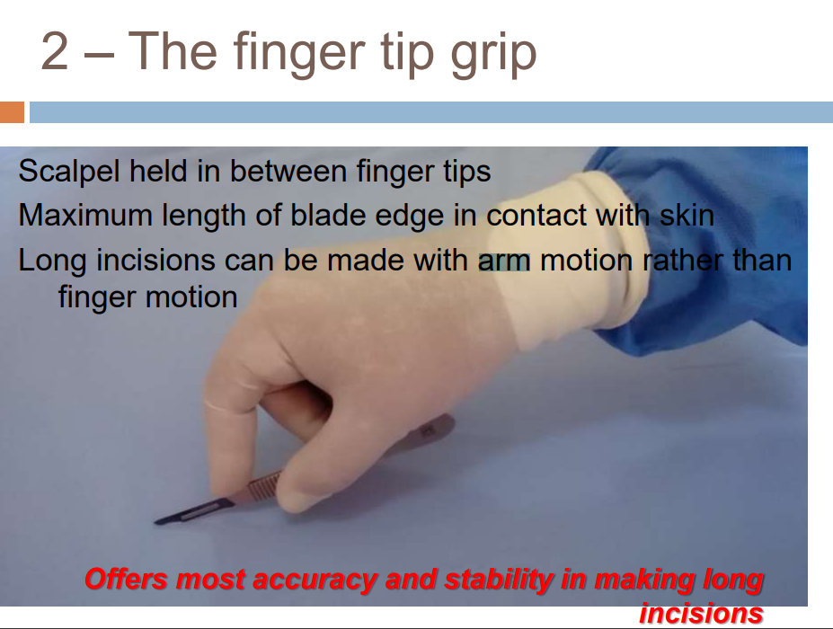

Figure fingertip grip (Dr. Ausaf Ahmed Khan ,2017)

**3.Third technique replicated: Pronated hand technique**

Accurate deep cuts of the tissue are made when the blade between the scissors are less than an acute angle. This is done by holding the scissors in a pronated hand in order to increase manoeuvrability

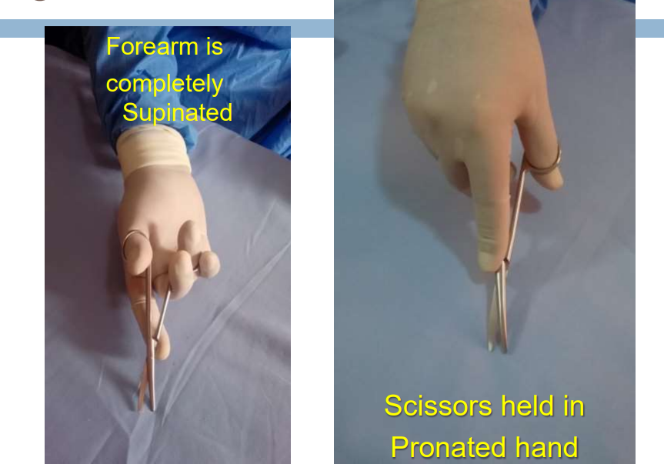

Figure two holding methods pronated hand(right) and supinated forearm(Dr. Khan 2017)

Other methodologies using other instruments/tools see section B 3 of the appendix

# Design Development (Method)

**Method (experimental and comparative)**

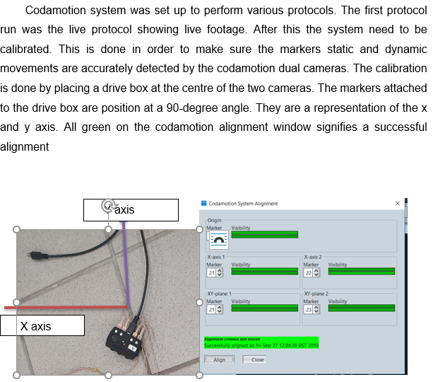

Figure Calibration

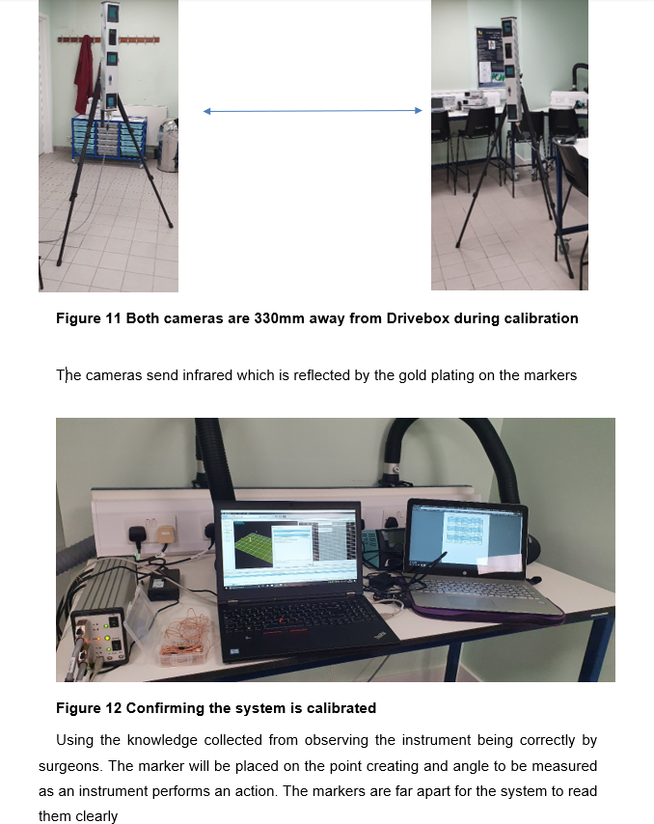

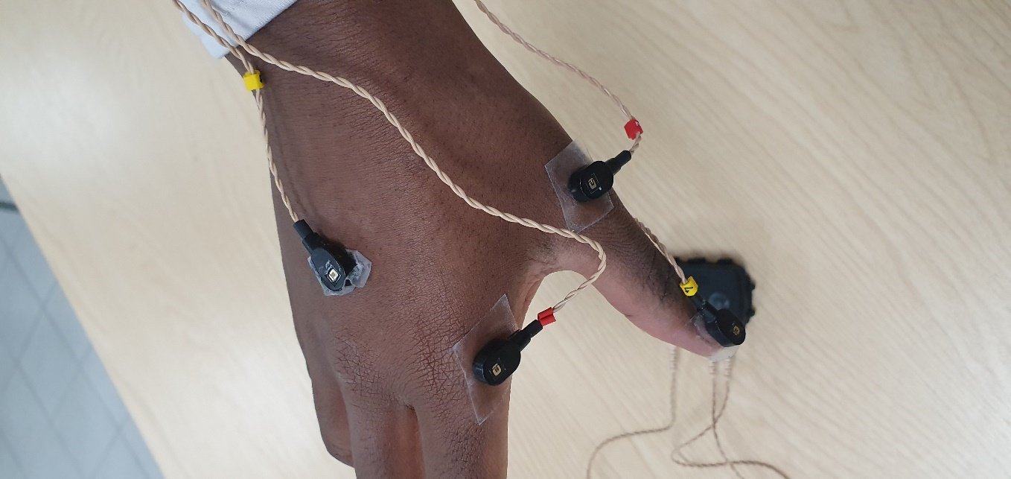

Origin point (marker 5)

Figure Position of markers on hand and angle created

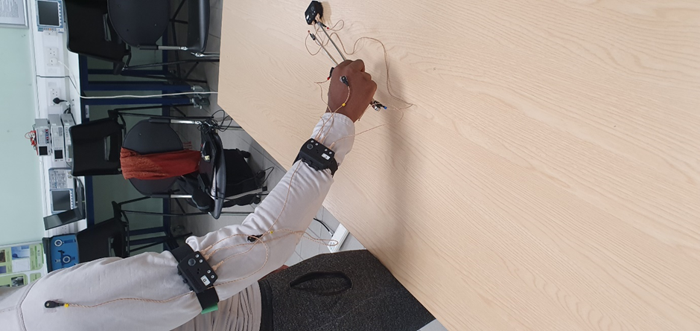

Origin point (marker 5)

Figure Position of markers on arm and angle created

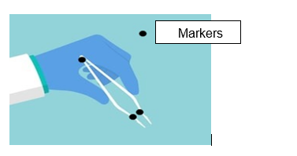

Figure Markers on medical device

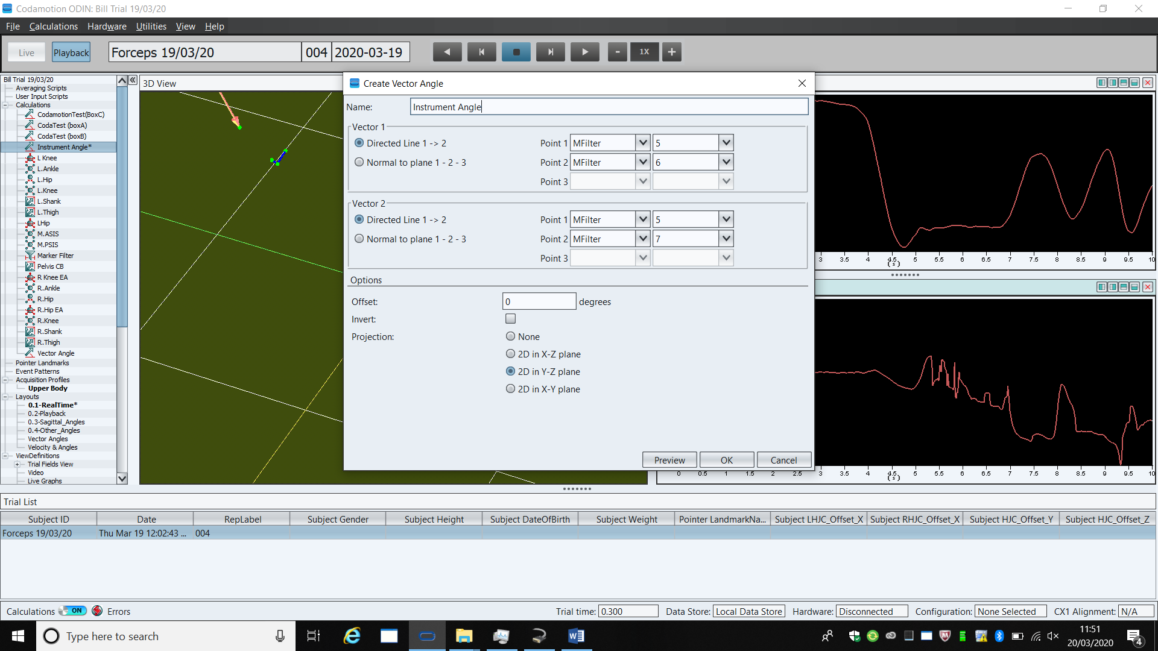

Once markers are placed vector angles where calculated from and origin point. In this case it was marker 5. The projection was on a Y-Z plane (shown above)

.

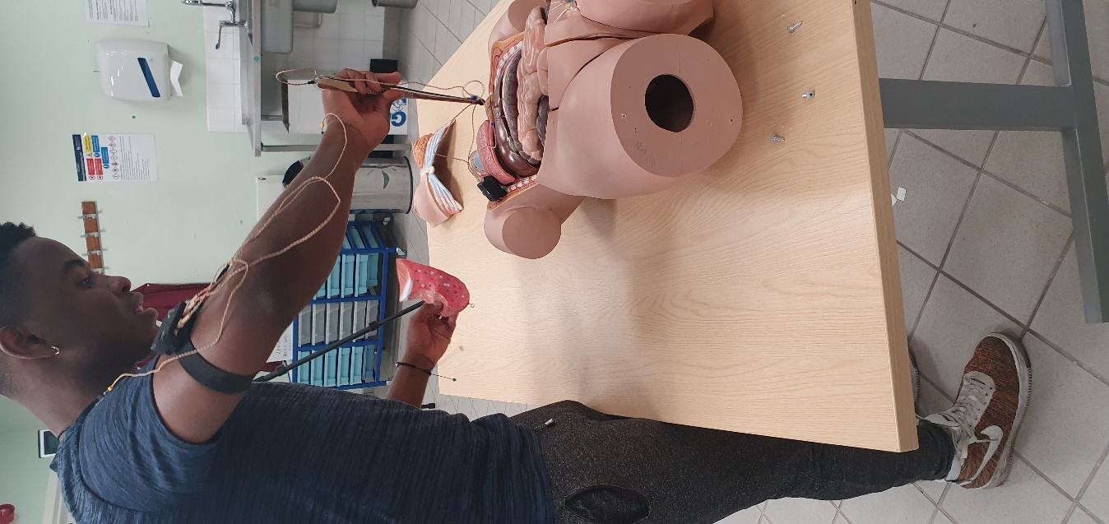

Figure The movements are done on an anatomically accurate manikin

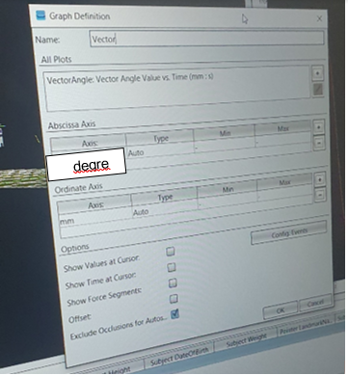

Figure This data was displayed on graph showing degrees and displacement

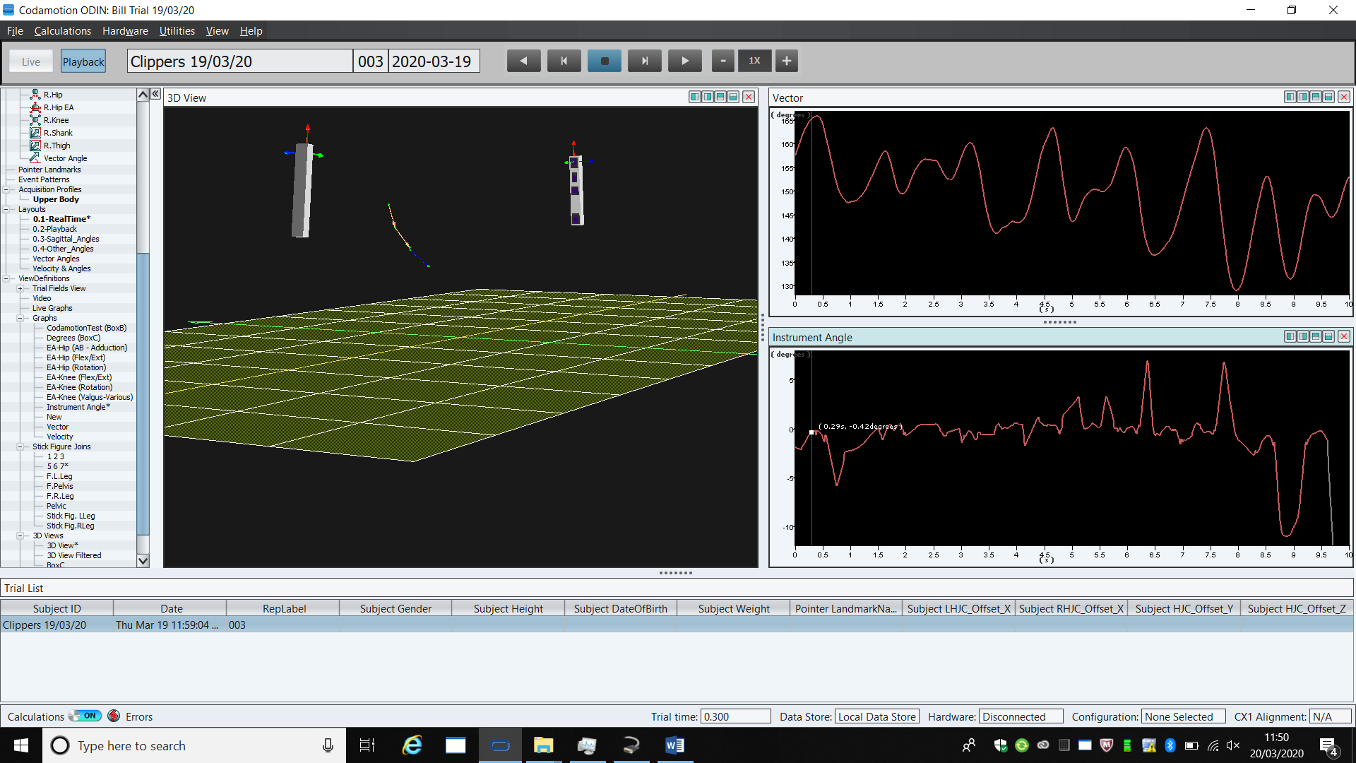

Figure showing the graphs to the left and the live protocol to the right

The movements will be measured and recorded at a sample rate of 200ms producing results in the form of a graph showing velocity and angles. The analysis of results determines what the participant needs to re-adjust. It could be their body position, posture or more specifically their arm and hand position which determine how the medical instrument/device is held. The participant then repeats the procedure until they perfect their technique. Initially, figure 13,15,16 were to be measured but due to time limitation, the data analysed was only from the arm (fig.14) and the instruments (fig.15). This represents data from arm and instrument.

The system was tested by measuring all five medical instruments shown in appendix section C. Only two were analysed and used in the methodology.

**Posture**

The method created was used in a coalition with the Alexander technique. The participant was consciously aware of their posture leading them to constantly readjust it as they perform incisions. Due to the light and less strenuous technique chosen the codamotion system was no longer needed as an observer/teacher.

**Preparations**



Figure Finger positions (Khan, 2017)

* The fingers on the left hand should be placed opposite the right hand holding the scalpel.
* Markers are made on the skin to show the start (a) and end of incision (b)

**Opening incision using a scalpel**

. Opening incision are done accurately and precisely at an angle of 90° to the skin. (Choudhary, 2014). The small and extremely sharp bladed lancet /scalpel was held between index finger and thumb. The forearm should be perpendicular to body and the arm should be positioned at a 90-degree angle (Braun, 2014).

This incision will be replicated and analysed in the analysis section

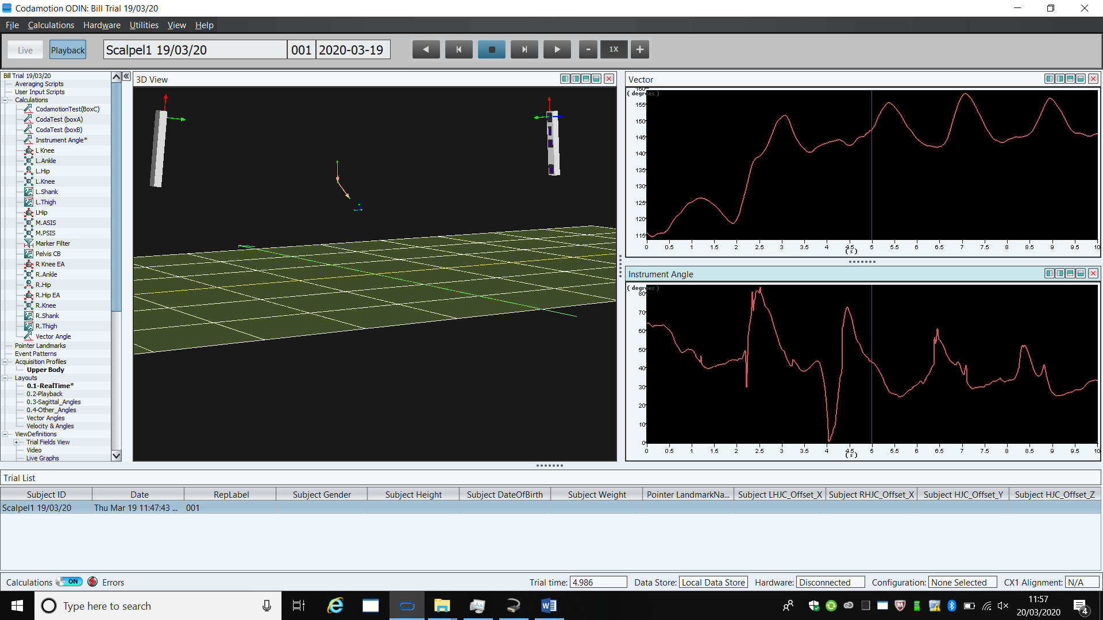

The right of the screen shows the movements of the markers placed on the arm and medical instrument. The data was collected in 10 seconds. A minimum of three repeats are done.



Figure Figure 9. The angle was between b-c aand incision was length is a-c (Dr. Ausaf Ahmed Khan 2017)

In ten seconds, the scalpel has moved from point a to c.

**fingertip grip**

The optimum incisions (figure 9) for quick wound healing are 0° to 45° was achieved using the fingertip grip(fig.10). In addition to the grip improving the accuracy of incision, it also permits the maximum blade edge to come into contact with the skin for a long incision. It relies mostly on arm motion. (Khan , 2017)



Figure fingertip grip (Dr. Ausaf Ahmed Khan ,2017)

The markers are placed on scalpel and arm and a 45-degree incision was done while the arm was at a 90-degree angle fixed position. (PFM medical ,2019) (Khan, 2017)

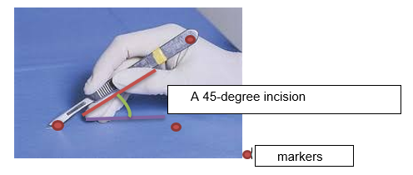

Figure angle of incision (Themes, U.F.O. 2016)

**Third technique replicated: Deep cuts made by scissors**

Scissors are less stable when they is an obtuse angle between the blades. This results in less accurate deep cuts of the tissue. The goal of this method is to make an angle of less than 90 degrees. This is done by holding the scissors in a pronated hand(fig.24) in order to increase manoeuvrability. A pronated hand can be supinated to 180 and pronated further by 90 degrees.

When holding the scissors, the distal phalanges should be within the rings while the index finger was placed on the joint of scissors in order to steady it. When making the deep cuts, the scissors are steadied by the index finger of the other hand. The cutting should be done with tips of scissors for accuracy. (B. Braun Surgical S.A., n.d.)



Figure two holding methods pronated hand(right) and supinated forearm(Dr. Ausaf Ahmed Khan, 2017)

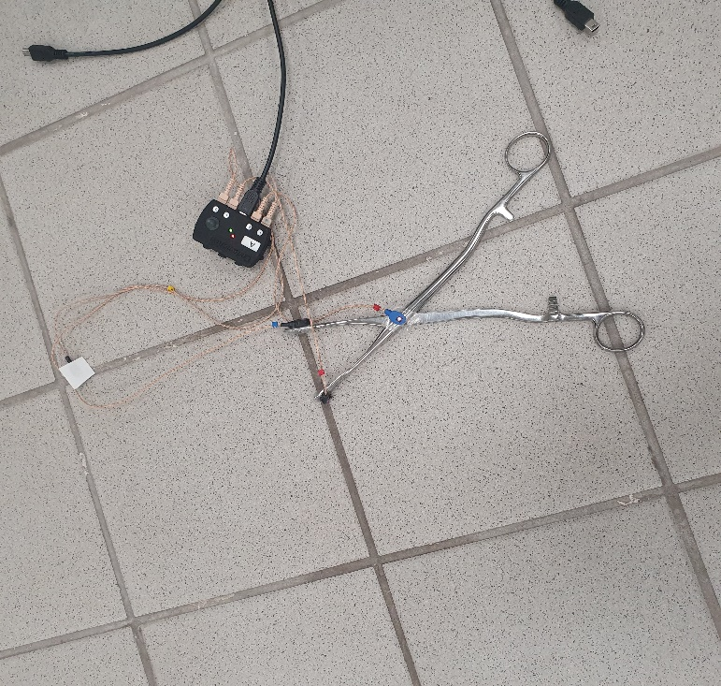

Figure Marker are placed on the three points of the scissors to measure the cutting angles

# Results and Analysis

Three repeats where done and the first and results are displayed below. Only the third trial angular velocity is measured.

**First technique replicated: initial opening incision**

**First trial results (arm)**

The results below show the position of the arm when making an incision. The first 30 values are off the ideal value of 90 degrees by an average value of 25 degrees.

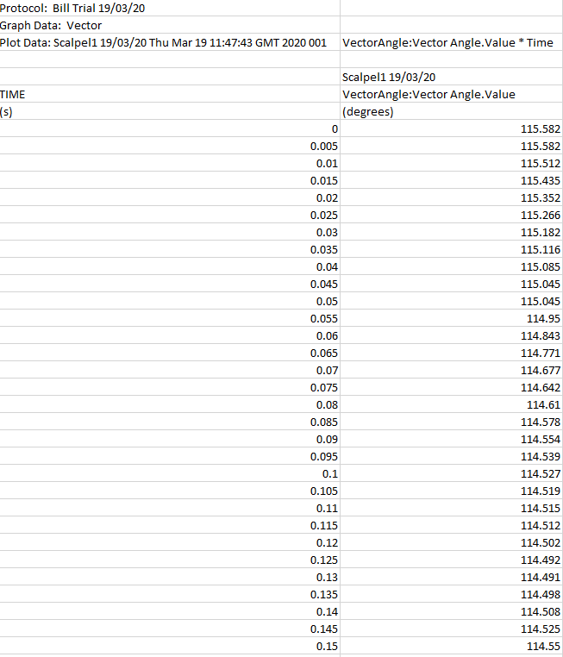

The last 30 values were of by an average value 55 degrees. The data illustrates an increase and fluctuating in degrees as time increased. It was also noted that the participant experienced loss in concentration and stability towards the end. They complained about fatigue.

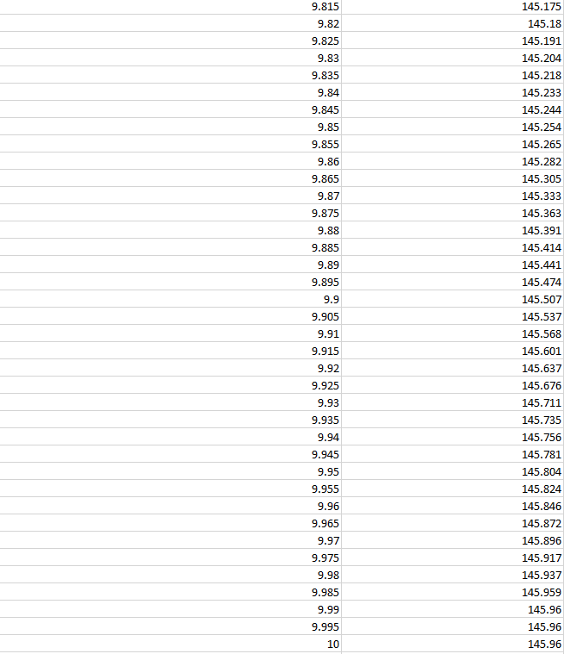  
All the data can be viewed in the appendix section C.

**third trial results (arm angle)**

For the first 30 values, the angles are off the ideal by an average value of 23 degrees. This is an improvement from the first trial.

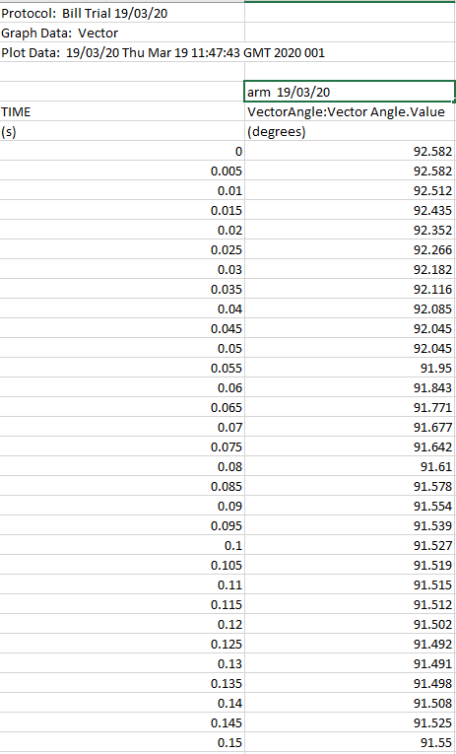

The last 30 values are off the ideal value by an average value of 32 degrees

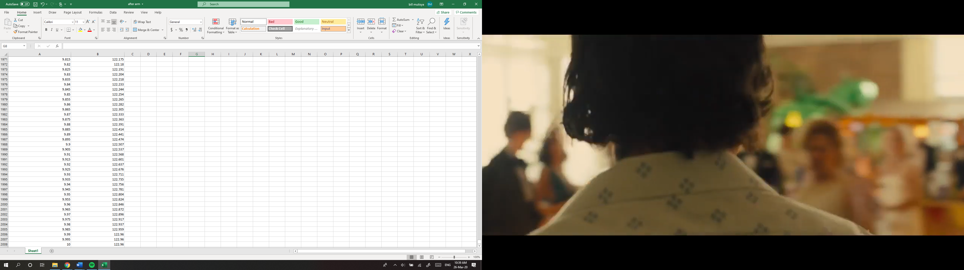

The graph above shows an overall lower velocity caused by reduced change in displacement.

Angular velocity = ((final angle) - (initial angle)) / time = change in position/time

The participant rushing through the procedure can be seen in the graph above. It demonstrates how increasing velocity (gradient value) at certain times caused a greater change in displacement (change in degrees). This can be seen in from the 2 to 3 seconds where they are a steep gradient of 150-120=130. The point of this experiment was to reduce this change and maintain a fixed angle of 90 degrees.

**First trial results (scalpel)**

The first 30 values show that the data was off the ideal 90-degree by an average value of 30 degrees.

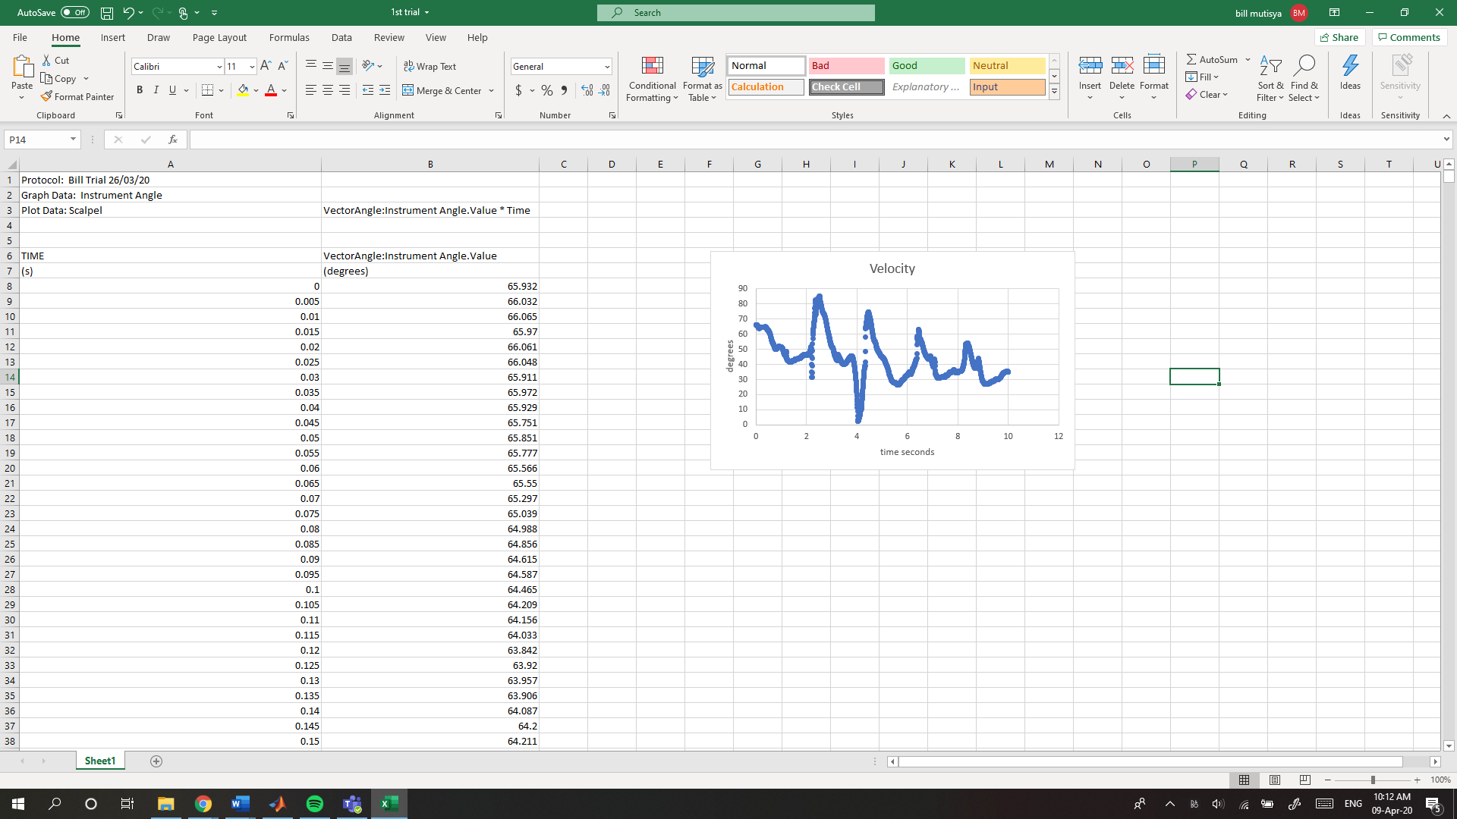

The last 30 values were off the ideal by an average value of 55 degrees.



**third trial results (scalpel angle)**

The first 30 values were off by an average value of 3 degrees. This shows a great improvement.



The last 30 value are off by an average value of 28 degrees.

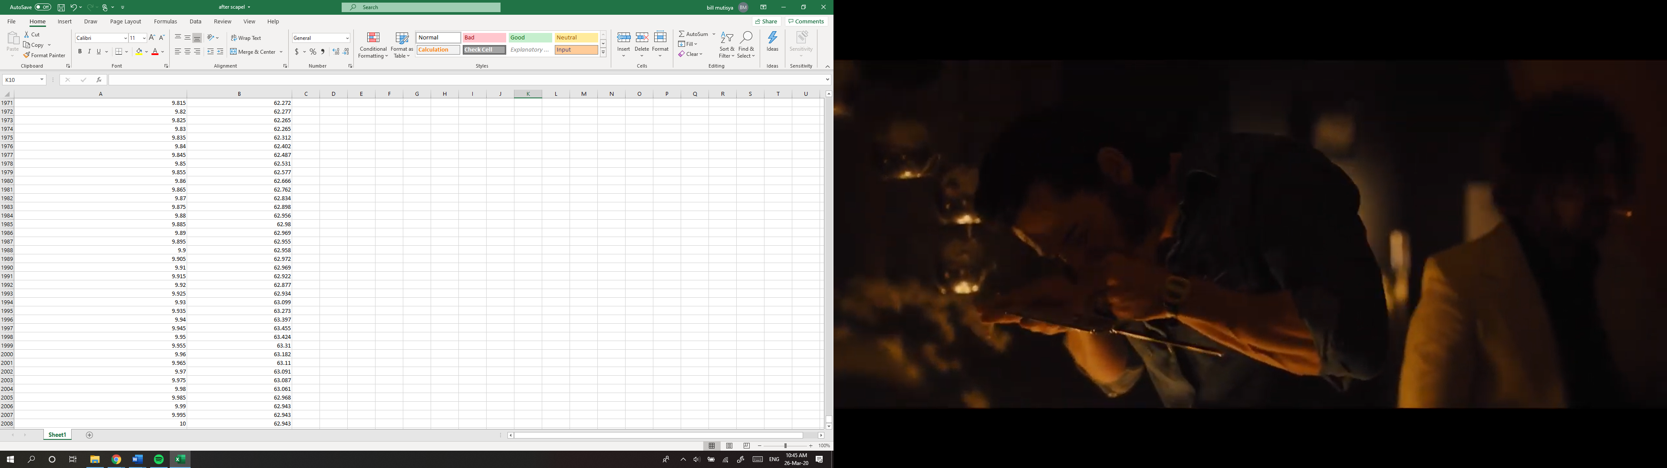

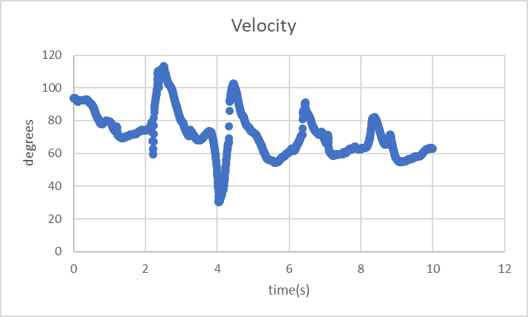

This shows steep gradients which means a higher velocity. The steepness reduce as the time goes on. The blue dotes show outliers

**Second technique replicated: fingertip grip**

**First trial results (arm angle)**

The first 30 values are off the ideal 45-degree by an average value of 90 degrees.

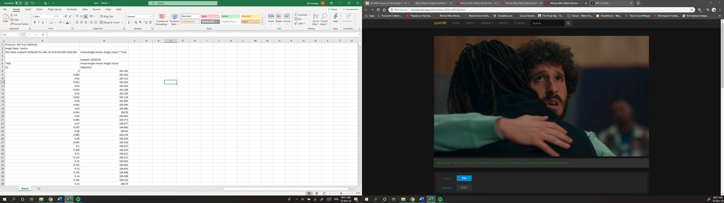

Towards the end of the 10 seconds the angles where off the ideal value by an average of 45 degrees

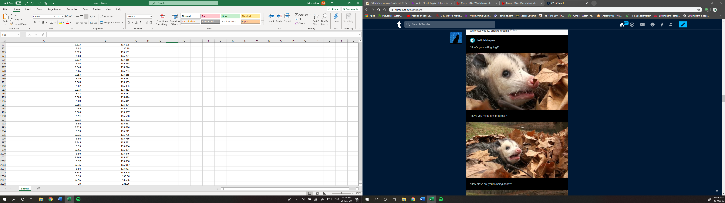

**third trial result (arm angle)**

The first 30 values. The values are off by an average value of 1 degree. This indicated positive progress.



The last 30 values are off by an average value of 28 degrees



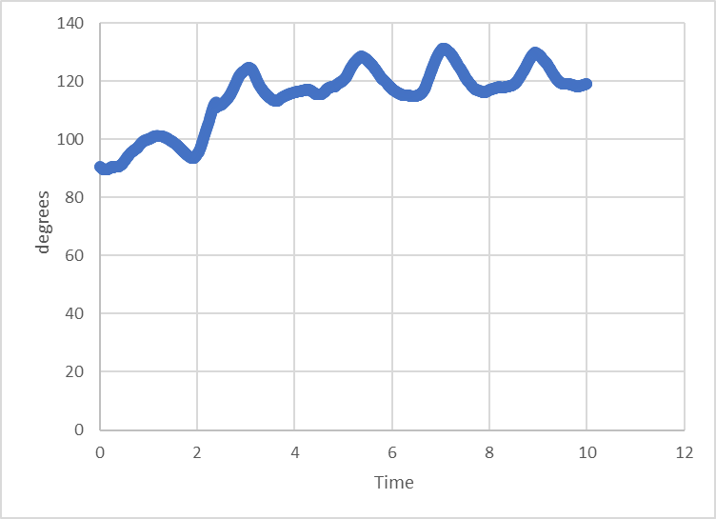

No Outliers. Steep gradients at 2.1 to 3 seconds.

**First trial results (scalpel angle)**

The first 30 values are off the ideal 45 degrees by 30 degrees

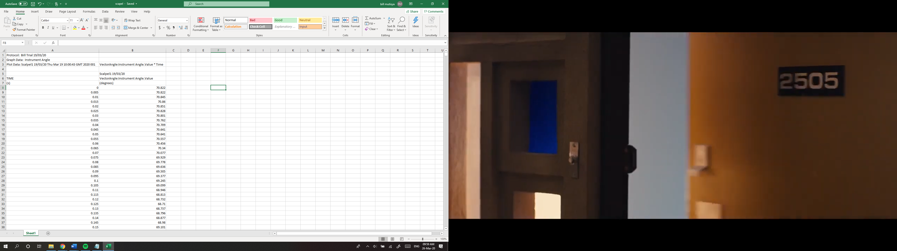

The last 30 values are off from the ideal by an average value of 51 degrees.

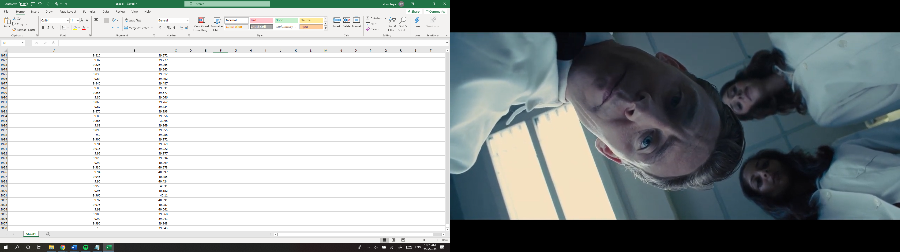

**third trial result (scalpel angle)**

The first 30 values are off the ideal vale by an average value of 45.0 degrees.



The last 30 values are off by an average value of 14 degrees



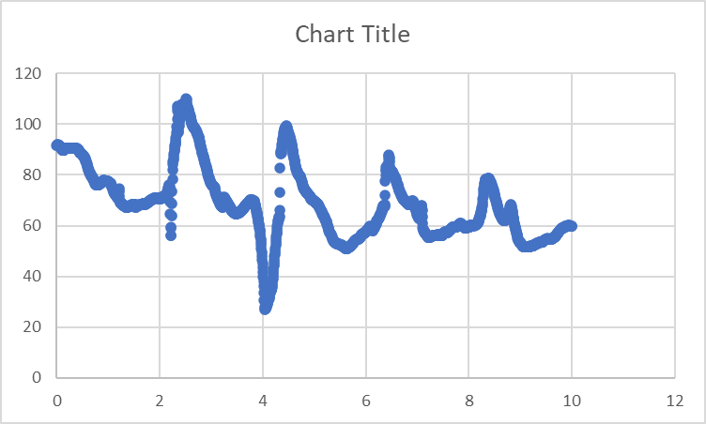

Outliers in the 2.1 and 4.2 second

**third technique: incision using scissors**



The degree-time graph represented velocity

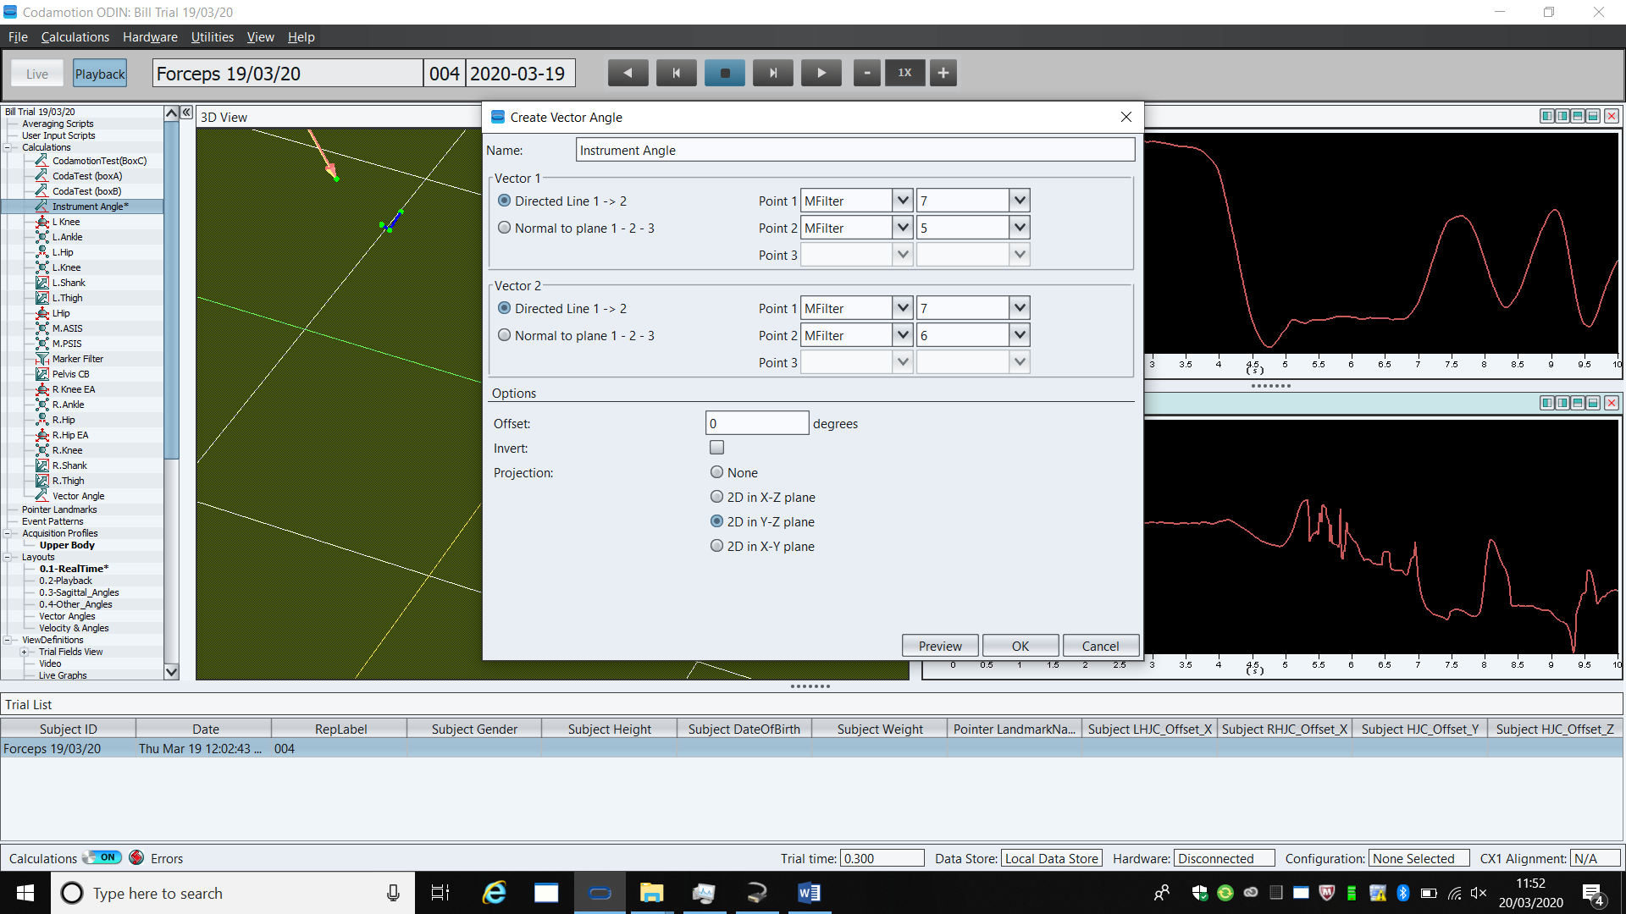

**Figure 27 The vector angles**

**first trial result (arm angle)**

The first 30 values are of the ideal fixed 90-degree angle by an average value of 64 degrees.

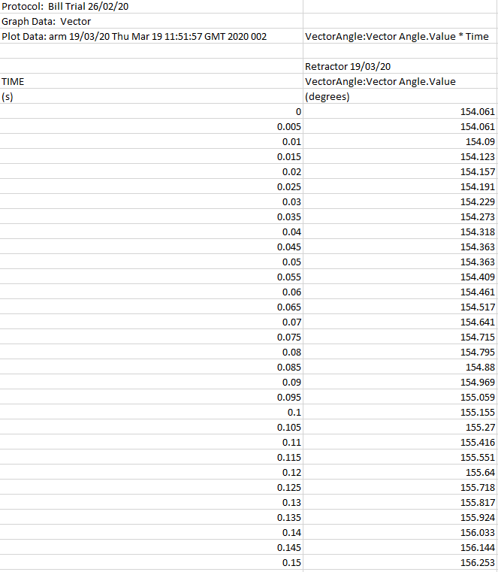

The last 30 values were off by an average value of 40 degrees

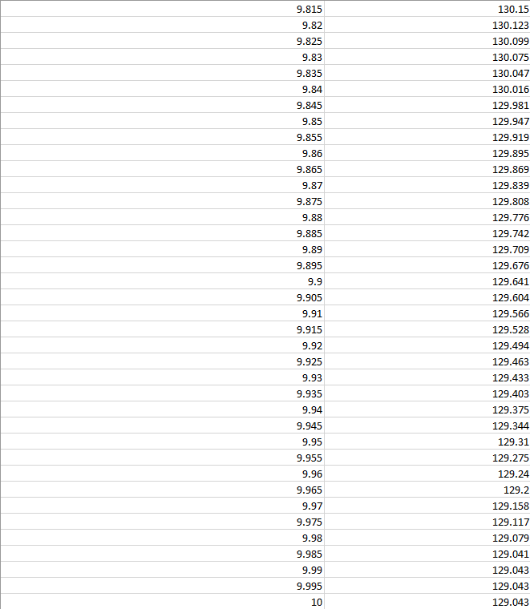

**third trial result (arm angle)**

The first 30 values were off the ideal value by an average value of 12 degrees .



The last 30 values were off the ideal value by an average value of 21 degrees



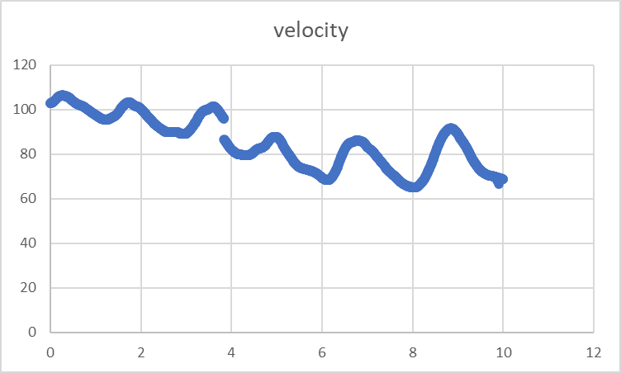

They was a gap at 3.5 seconds. This was caused by participant losing stability resulting in them moving away from camera detecting markers

**first trial result (scissors angle)**

The ideal incision should be made at an angle of less than 90. The first 30 values are less than 90 degrees (an acute angle). The difference was an average value of 70 degrees.

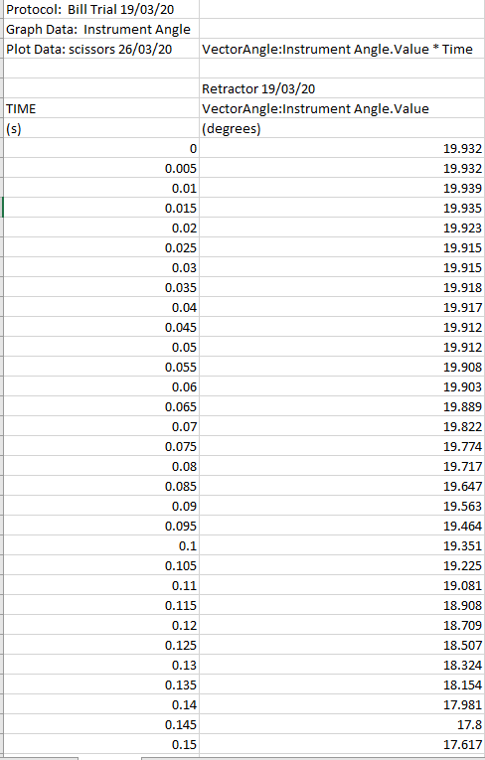

The last 30 values were less than 90 degrees (an obtuse angle) required.

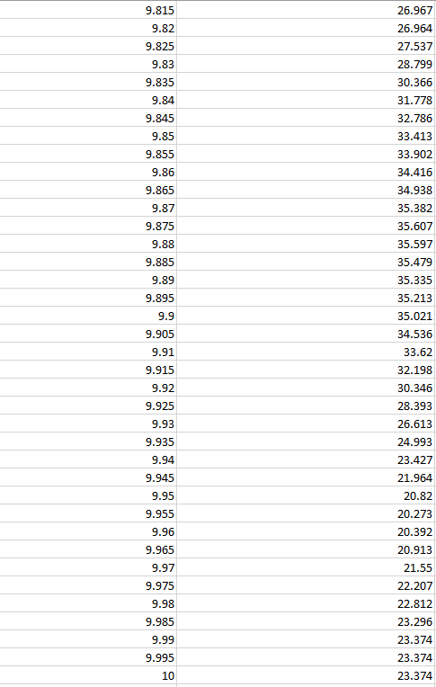

**third trial result (scissors angle)**

The last 30 values were less than 90 degrees (an obtuse angle) by an average value of 66 degrees.



The last 30 values were less than 90 degrees (an obtuse angle)



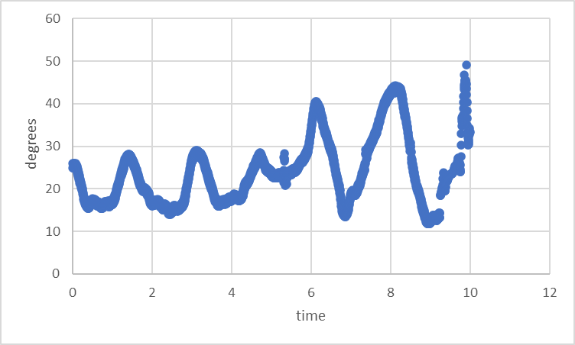

Outlier are seen in the 9th second.

All the medical instruments data and graphs are in appendix section C

# Discussion

**Technical problems and solutions**

* The small and mobile codamotion system is very sensitive but it cannot adapt to reading movements made in positions outside its known axis. This is its greatest limit and strength This means it can be used to detect minute changes if it is done within the cameras viewing angle. This is a technical problem that can be solved using technical protocols that can be adopted while using codamotion. This include.

1. Readjusting the motion analysis system camera or using more cameras. The disadvantage of this was that it took a lot of time to do.

**Discussion on data in relation to literature**

“See One, Do One, Teach One” method (Kotsis , 2013) was put into practice in this experiment. The hypothesis was that by observing surgeons and their movements during the procedure the participant would able to perfectly mimic it in the experiment by maintaining a fixed angular position of the instrument to the skin while performing the incision or procedure. This was done while sustaining the correct angular arm position and good posture. The posture was monitored and improved by simply applying the Alexander technique. This was done by the participant being cognizant of their own posture and the way they stand, leading to readjusting whenever he felt strain or fatigue on his lower back. (Pramod 2019). The general trend in the results from the motion analysis showed that the participant was able to maintain a value close to the ideal angular position for all three procedures and techniques. All the values similarity to ideal value improved significantly in the third trial. This proves that repeating the experiment produces better results. The last 30 values show that towards the end of the 10 second period the participant experienced moments of lost stability. This was indicated in the results by the fluctuating of degrees measured and an increased number of outliers This was deduced to have been caused by the participant’s experiencing weariness towards the end of the procedure. This shows that Kotsis (2013) method was applicable to a certain extent. It showed that it was possible to learn and mimic through observing and self-teaching, but more time is needed to hone and perfect skills. The fatigue experienced by the participant in the last few seconds reduced gradually in the third trial. This was a result of the muscles got accustomed to the strain.

The fluctuation of degrees measured was also caused by the participant accelerating his incision speed at a random time. The participant failed to maintain a steady velocity of movement because of the lack of practice in pacing. These types of mistakes confirm Sweeney (2012) theory that more time practising and educating students was needed. It cannot be rushed and replicated by simply viewing and measuring as Kotsis (2013) insinuated. They need to be trained using various teaching methods until it is muscle memory

The procedures and techniques were simulated safely on an anatomical manikin. The analysis from the motion analysis system showed that the participant did learn basic surgical techniques and procedures. (Saifi 1990) (Anastakis,1999) (Badash, 2016) (Brown,2013). This was demonstrated by how their performance results improved the more time they did it

(appendix section D.1)

# Conclusions

The objective was to collect and analyse the data which was done successfully and in detail.

The repeats proved the ability to improve technique and performance of the procedure. The data also confirms an increase in accuracy and precision as more repeats. The lapse in progress where when the participant experienced fatigue.

In conclusion, the experiment yielded a lot of data that could be used in other scientific research such as mapping out human movements to be replicated by surgical robots.

# Recommendations

* Larger sample size with diverse backgrounds - small sample size (few participants) may be the cause of the inflated false discovery rate. It makes it difficult to detect patterns and makes it easier to detect false errors.
* A higher sample rate – allows the taking of more data reading which gives us a better understanding of movement.
* Using more real and virtual markers in order to collect more data when recording movements using the codamotion system.
* Use a different motion detector system to perform the same experiment then compare it to the data collected from codamotion. This will be used to further prove the integrity of the data.

# References

Agha, R.A. and Fowler, A.J. (2015). The Role and Validity of Surgical Simulation. International Surgery, 100(2), pp.350–357. Available at: https://www.ncbi.nlm.nih.gov/pmc/articles/PMC4337453/. [Accessed 3 Dec. 2019].

Akhtaruzzaman, Md & Shafie, A.A. & Khan, Md Raisuddin. (2016). GAIT ANALYSIS: SYSTEMS, TECHNOLOGIES, AND IMPORTANCE. Journal of Mechanics in Medicine and Biology. 16. 1630003. 10.1142/S0219519416300039. [Accessed 5 Dec. 2019].

Albayrak, A., van Veelen, M.A., Prins, J.F., Snijders, C.J., de Ridder, H. and Kazemier, G. (2007). A newly designed ergonomic body support for surgeons. Surgical Endoscopy, 21(10), pp.1835–1840. [Accessed 4 Nov. 2019].

Anastakis DJ, Regehr G, Reznick RK, et al.(1999) Assessment of Technical Skills Transfer from the Bench Model to the Human Model. Am J Surg; pg 177; 167–70. [Accessed 9 Apr. 2020].

Antony (2018). Advantages Disadvantages and Applications of Motion Capture. Available at: https://www.streetdirectory.com/travel\_guide/139425/technology/advantages\_disadvantages\_and\_applications\_of\_motion\_capture.html [Accessed 5 Dec. 2019].

Ausaf Khan (2017). Techniques in the use of surgical tools. Available at: https://www.slideshare.net/ausafkhan10/techniques-in-the-use-of-surgical-tools [Accessed 3 May 2020].

B. Braun Surgical S.A. (2019.) Surgical Instrument: best practices. Available at: https://www.bbraun.com/en/products-and-therapies/wound-closure/knotting-expert-club/surgical-instrument-best-practices.html#scalpel [Accessed 19 Feb. 2020].

Badash, I., Burtt, K., Solorzano, C.A. and Carey, J.N. (2016). Innovations in surgery simulation: a review of past, current and future techniques. Annals of Translational Medicine, 4(23), pp.453–453. Available at: https://www.ncbi.nlm.nih.gov/pmc/articles/PMC5220028/#r7 [Accessed 3 Dec. 2019].

Brown, D. (2013). The Role of Simulation in the Learning of Surgical Skills. The Bulletin of the Royal College of Surgeons of England, 95(9), pp.292–295. [Accessed 9 Apr. 2020].

Brooke Walker (2017). Duke Surgery Introduces Ergonomics Program to Improve Surgeon Health. Available at: https://surgery.duke.edu/news/duke-surgery-introduces-ergonomics-program-improve-surgeon-health [Accessed 8 May 2020].

Bumc.bu.edu. (2019). Suturing Basics » Surgery | Boston University. Available at: https://www.bumc.bu.edu/surgery/training/technical-training/suturing-basics/ [Accessed 4 Nov. 2019].

Bumc.bu.edu. (2019). Suturing Basics » Surgery | Boston University. Available at: https://www.bumc.bu.edu/surgery/training/technical-training/suturing-basics/ [Accessed 4 Nov. 2019].

Cleveland Clinic. (n.d.). Cystectomy Procedure Details. Available at: https://my.clevelandclinic.org/health/treatments/21049-cystectomy/procedure-details [Accessed 16 Apr. 2020].

Choudhary, P. (2014). How to hold the scalpel while making Surgical Incision. YouTube. Available at: https://www.youtube.com/watch?v=IhjekrZwKpA [Accessed 19 Feb. 2020].

Frank, D.L., Khorshid, L., Kiffer, J.F., Moravec, C.S. and McKee, M.G. (2010). Biofeedback in medicine: who, when, why and how? Mental health in family medicine, 7(2),pp.85–91.Available at: https://www.ncbi.nlm.nih.gov/pmc/articles/PMC2939454/.[Accessed 19 Feb. 2020].

Hanks, J.B. (2019). Simulation in Surgical Education: Influences of and Opportunities for the Southern Surgical Association. Journal of the American College of Surgeons, 228(4), pp.317–328. [Accessed 16 Apr. 2020].

He, J.C., Zosa, B.M., Schechtman, D., Brajcich, B., Savakus, J.C., Wojahn, A.L., Wang, D.Z. and Claridge, J.A. (2017). Leaving the Skin Incision Open May Not Be as Beneficial as We Have Been Taught. Surgical infections, 18(4), pp.431–439. Available at: https://www.ncbi.nlm.nih.gov/pubmed/28332921 [Accessed 5 Dec. 2019].

HOW TO: OPERATE NEPTUNE SUCTION MACHINE. (2019). YouTube. Available at: https://www.youtube.com/watch?v=jEmeCoadl2k [Accessed 5 Dec. 2019].

Incision: Using the Scalpel: You can Score Every Time!. (2019). [image] Available at: https://www.youtube.com/watch?v=oLa6cX2WoxY [Accessed 4 Nov. 2019].

Jacobaeus, H.C. (1923). The Cauterization of Adhesions in Artificial Pneumothorax Treatment of Pulmonary Tuberculosis under Thoracoscopic Control. Proceedings of the Royal Society of Medicine, 16, pp.45–62. [Accessed 3 Dec. 2019]

Kalis V, e. (2019a). Evaluation of the incision angle of mediolateral episiotomy at 60 degrees. - PubMed - NCBI. Ncbi.nlm.nih.gov. Available at: https://www.ncbi.nlm.nih.gov/pubmed/21247571 [Accessed 4 Nov. 2019].

Kalis V, e. (2019b). The incision angle of mediolateral episiotomy before delivery and after repair. - PubMed - NCBI. Ncbi.nlm.nih.gov. Available at: https://www.ncbi.nlm.nih.gov/pubmed/18674760 [Accessed 4 Nov. 2019].

Kotsis, S.V. and Chung, K.C. (2013). Application of the “See One, Do One, Teach One” Concept in Surgical Training. Plastic and Reconstructive Surgery, 131(5), pp.1194–1201. Available at: https://www.ncbi.nlm.nih.gov/pmc/articles/PMC4785880/ [Accessed 4 Dec. 2019].

Mimic Simulation (2018). Mimic Simulation | Leader in Robotic Surgery Simulation & Training.. Available at: https://mimicsimulation.com/ [Accessed 5 Dec. 2019].

Morel, M., Bideau, B., Lardy, J. and Kulpa, R. (2015). Advantages and limitations of virtual reality for balance assessment and rehabilitation. Neurophysiologie Clinique/Clinical Neurophysiology, 45(4–5), pp.315–326. [Accessed 16 Apr. 2020].

NHS Choices (2020). Alexander technique. Available at: <https://www.nhs.uk/conditions/alexander-technique/>. [Accessed 16 Apr. 2020].

Pfm medical (2019). Standard Incision Scalpel: Product catalogue. Available at: https://www.pfmmedical.com/en/productcatalogue/featherr\_micro\_scalpels/standard\_incision\_scalpel-1/index.html [Accessed 4 Nov. 2019].

Papanikolaou, I.G., Haidopoulos, D., Paschopoulos, M., Chatzipapas, I., Loutradis, D. and Vlahos, N.F. (2019). Changing the way we train surgeons in the 21th century: A narrative comparative review focused on box trainers and virtual reality simulators. European Journal of Obstetrics, Gynecology, and Reproductive Biology 235, pp.13–18. Available at: https://www.ncbi.nlm.nih.gov/pubmed/30772529 [Accessed 5 May 2020].

Pramod P.(2019).Alexander technique.com. Available at: https://alexandertechnique.com/articles/alexandertechniqueposter.pdf [Accessed 3 Dec. 2019].

Reddy, P.P., Reddy, T.P., Roig-Francoli, J., Cone, L., Sivan, B., DeFoor, W.R., Gaitonde, K. and Noh, P.H. (2011). The Impact of the Alexander Technique on Improving Posture and Surgical Ergonomics During Minimally Invasive Surgery: Pilot Study. Journal of Urology, 186(4S), pp.1658–1662. Available at: https://www.michaeldfrederick.com/wp-content/uploads/2014/08/Impact-of-AT-in-improving-posture-during-minimall-invasive-surgery-paper.pdf [Accessed 4 Dec. 2019].

Rogers, S.O., Gawande, A.A., Kwaan, M., Puopolo, A.L., Yoon, C., Brennan, T.A. and Studdert, D.M. (2006). Analysis of surgical errors in closed malpractice claims at 4 liability insurers. Surgery, 140(1), pp.25–33. [Accessed 4 Dec. 2019].

Saifi J, Chang BB, Paty PSK, Kaufman J, Leather RP, Shah DM.(1990)( An animal model for the instructing and study of in-situ arterial bypass. J Vasc Surg 12:538–40. [Accessed 9 Apr. 2020].

Salam, G. and Amin, J. (2019). The Basic Z-Plasty. Aafp.org. Available at: https://www.aafp.org/afp/2003/0601/p2329.html [Accessed 4 Nov. 2019].

Sciencedirect.com. (2019). Skin Incision - an overview | ScienceDirect Topics. Available at: https://www.sciencedirect.com/topics/medicine-and-dentistry/skin-incision [Accessed 4 Nov. 2019].

Sklarcorp.com. (2018). Backhaus Towel Clamp - Towel Clamps - Forceps | Sklar Surgical Instrument. Available at: https://www.sklarcorp.com/forceps/towel-clamps/backhaus-towel-clamp-5-1-4.html [Accessed 5 Dec. 2019].

STERIS Instrument Management Services. (2012). Langenbeck Extra Large Retractor Single Blade Size 90mm X 20mm 215mm PH252288 | STERIS Instrument Management Services. Available at: https://www.steris-ims-instrument.com/shop/langenbeck-extra-large-retractor-single-blade-size-90mm-x-20mm-215mm-ph252288/ [Accessed 5 Dec. 2019].

Surtex Instrument Limited (2017). Howarth Periosteal Elevator. Surtex-instrument.co.uk. Available at: https://www.surtex-instrument.co.uk/howarth-periosteal-elevator [Accessed 5 Dec. 2019].

Sutherland, L.M., Middleton, P.F., Anthony, A., Hamdorf, J., Cregan, P., Scott, D. and Maddern, G.J. (2006). Surgical Simulation. Annals of Surgery, 243(3), pp.291–300. Available at: https://www.ncbi.nlm.nih.gov/pmc/articles/PMC1448942/ [Accessed 5 Dec. 2019].

Sweeney, W. (2012). Teaching Surgery to Medical Students. Clinics in Colon and Rectal Surgery, 25(03), pp.127–133. Available at: https://www.ncbi.nlm.nih.gov/pmc/articles/PMC3577572/#BR25127-2 [Accessed 4 Dec. 2019].

Tan, S.S.Y. and Sarker, S.K. (2011). Simulation in surgery: a review. Scottishmedical journal, 56(2), pp.104–9. Available at: https://www.ncbi.nlm.nih.gov/pubmed/21670138 [Accessed 9 Apr. 2020].

VTVEK DATTA, SEAN MACKAY, ARA DARZP & DUNCAN GILLIES (2001) Motion Analysis in the Assessment of Surgical Skill, Computer Methods in Biomechanics and Biomedical Engineering, 4:6, 515-523, [Accessed 3 Dec. 2019].

‌

# Appendix

**section A**

**1.Surgical training**

Sweeney (2012) offers a different more applicable opinion on learning by stating that, they has been an increase in the amount of surgical knowledge and technical skills needed to be trained and yet they have been a decrease in time students spend on a surgical rotation. Educators’ solution to this massive challenge f to create realistic learning objectives for the student using effective traditional teaching methods as well as applying new modalities where appropriate e.g. technology-based learning. This cannot work without the student showing initiative for self-learning in order for this system to work.

The most common teaching method for instilling medical-based information continues to be lectured to large groups of students taught for long periods of time. This setting is not optimal for technical skills and problem-solving skills training. One solution to this is internet sites that provide basic surgical knowledge. This allows the replacement of the lectures with more active learning methods

Another solution to this is conducting small group learning sessions which often require more faculty and more faculty time. This is quite difficult because clinically active surgeons already have many demands.

An alternative method for teaching is mentoring. A surgical teaching mentorship model ideally should be one-on-one, but it can be up to three students at a time due to demand. The problem with this type of teaching is the surgeons get overwhelmed at times with the workload and forget or do not get a chance to see and advise the student (Sweeney, 2012).

A detailed analysis of simulation proves that its use can be justified in three ways.

Pedagogical, ethical, and practical. Pedagogical, simulations permit the student to gradually introduce various aspects of a complex procedure at their own pace and at their own time. This is a learner-centred system allowing them to repeat what the need to further improve or rush through what they already understand. It allows them to attempt new techniques or procedures in a stable environment with a system that gives instantaneous feedback (Brown, 2013). In terms of ethics, simulations stop the patient from being used as guinea pigs when testing out new surgical procedures. If the new procedure still must be done the surgeon can practice it in the simulation and if it is successful in replicating it makes him/her more confident in performing the procedure on a patient. Brown (2013).

Practically, simulations simply reduce both surgeon and patient risk. The surgeon is less likely to injure himself/herself when using specialized instruments. Saifi (1990) proved that student’s performance had improved significantly when they trained on a simulator. Furthermore, Anastakis (1999) confirmed that basic skills learned on a simulator could be applied effectively as on a cadaver. This proves that skills were transferable.

**2.Modern-day use of simulations, motion analysis systems in the medical field**

In terms of motion analysis, dexterity is important in the selection of trainees to specialize such as surgery specifically laparoscopic surgery. The Imperial College Surgical Assessment Device (ICSAD) is a motion analysis system that uses positional data which is converted to data reflecting the surgeon’s dexterity. Its biggest problem is cost. The hardware and software are quite expensive and sometimes may be fragile. The technology becomes obsolete after a few years as a result of better software, hardware, and techniques being invented. (Antony,2018)

**Virtual reality**

Virtual reality (VR) and robotic simulators such as Maestro AR are increasingly being used in surgical training programs. They are quicker and cost-effective in the long run. The drawback is usually the initial purchase of software and hardware. They are quite expensive, and training to use them is time-consuming. The software also needs to be constantly updated and the hardware needs to be treated with care. (Mimic Simulation 2018) (Morel et al. ,2015). HoloLens headset was initially going to be used to virtually see the angles created in real-time and to replicate an operating room. It was not used because of time limitations and a lack of a functional software development kit needed to code it.

**3.Posture analysis of surgeons during surgery**

The main ergonomic challenge during surgical procedures is are the surgeon’s posture. An example is a laparoscopic surgical procedure that allows a surgeon to access the inside of the abdomen and pelvis by making small incisions in the skin. Due to the position of the patient during open surgery, surgeons tend to lean forward toward or even over the surgical field to see and manipulate the tissue. Ahead- and back-bent posture with a twisted torso is the posture of the surgeon during most open surgical procedures. During laparoscopic procedures, the posture of the surgeon is characterized by a head and back straight posture.

The solution to this lies in Pramod (2019) article which talks about the Alexander technique. This is a process of psychophysical re-education of the body. An example of this is of a teacher or participant observes your movement and posture (NHS Choices ,2020). They then advice you on how to maintain balance and reduce strain on the back . It is done to improve postural balance and coordination, permitting movement with minimal strain and maximum ease. A pilot study was done, and the results showed subjects improved the ability to complete FLS™ exam. It also showed improvement in surgical ergonomics, endurance and posture decrease surgical fatigue, and the incidence of repetitive stress injuries to laparoscopic surgeons. (Pramod 2019)

One of the methods considered uses a body-support design which provides the perfect compromise between the spine and arm position (Albayrak, 2007). This can be used to reduce the fatigue of surgeons performing open and invasive procedures. They are expensive and difficult to obtain.

Codamotion combined with Alexander's technique will produce the most detailed results. This is down to the motion detector system (acting as a teacher) detecting movement accurately and producing data which makes the participant aware of their posture and whether they need to adjust it.

**Section B**

**1.Initial approach**

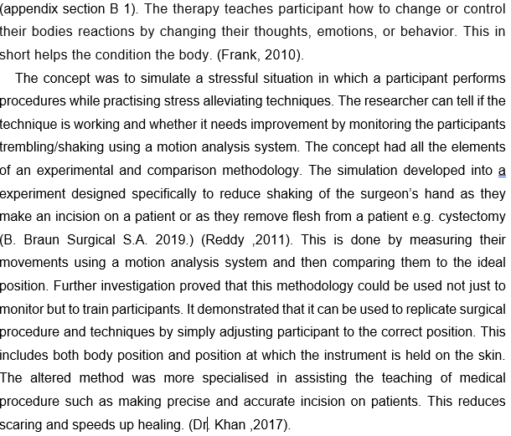The project was initially an application of biofeedback therapy. During a biofeedback therapy session. A therapist attaches electrical sensors to the participant's body. These sensors are used to monitor the participant’s muscle tension, heart rate, and breathing. This information in the form of data is fed back to participant and researcher through cues, such as changes of measured values on a monitor.

The participant performs an incision which is then compared to how a trained surgeon or manufacture does it. If it does not match the participant re-adjusts themselves and retry the procedure. Multiple medical instruments have measured and analyzed. This was done on a real anatomical manikin. The angles measured were increased from not just the hand but to various parts of the arm. The posture will also be studied and improved using the Alexander technique.

**The first experiment considered: Stress management using conditioning**

Research started with the application of biofeedback therapy. In a biofeedback therapy session, a therapist attaches electrical sensors to different parts of your body. These sensors are used to monitor the participant’s brain waves, skin temperature, muscle tension, heart rate, and breathing. This information in the form of data is fed back to participant or doctor through cues, such as changes on a monitor, a beeping sound, or a flashing light. The feedback teaches participants how to change or control their body's reactions by changing their thoughts, emotions, or behavior. This, in short, helps the condition of the body. (Frank, D.L., Khorshid, L., Kiffer, J.F., Moravec, C.S. and McKee, M.G. 2010).

. The simulation game was designed specifically to reduce shaking of the surgeon’s hand as they make an incision on a patient or as they remove flesh from a patient e.g. cystectomy (B. Braun Surgical S.A. 2019.) (Reddy, T.P 2011). In sports, it can be used to steady the hand of a dart thrower. (appendix section B)

The simulation created was a game where the player was to remove different parts of the body’s anatomy. The grabbing was to be done using tweezers on a virtual anatomical manikin augmented onto a rectangular whiteboard with markers on its four edges(fig.19). The markers have placed the whiteboard in order to detect movement of tweezers on the virtual manikin. All this is seen through a HoloLens.

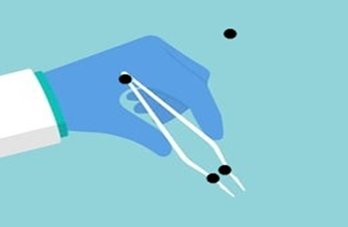

markers

Figure tweezers

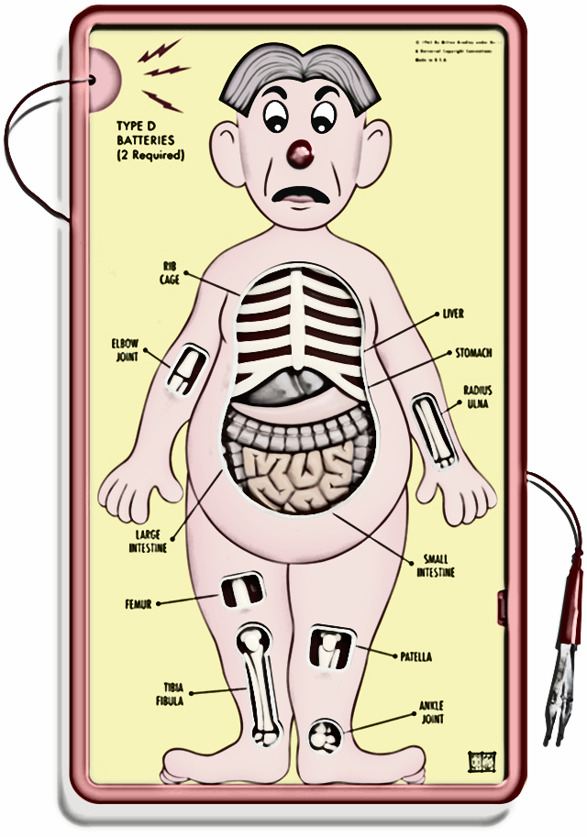

Figure Whiteboard with augmented reality manikin

The HoloLens was to be used to relays data about the manikin and marker position in real-time to the researcher and participant wearing glasses. The movement of the tweezers where to be measured using the codamotion system. This is implemented by placing three markers on the hand, elbow, and shoulder creating an angle that can be measured in real-time through the HoloLens. Markers are also be placed on the tweezers (fig.18) or a weighted object to determine movement angles. The angles measured to represent the tremors of the participant. The goal was to reduce this by adding calming sounds or light to act as positive reinforcement. The more the patient tremor angle increased (this represented shaking) the more calming sounds, light, and other conditions will be altered to create peaceful conditions. In order to create a stressful situation, a noise would increase and decrease in loudness as tweezers moved towards or away from the edges of the whiteboard. A loud annoying sound was produced by the software when moving toward the edges of the whiteboard and vice versa. This data was collected and processed. This is used in further research to determine the stress cause and how to reduce/alleviate it. The advantages of these methods were that It gave real-time results which were seen through virtual reality so a lot more scenarios can be created and more conditions altered.

This idea and experiment were altered once the codamotion system could not be linked with Hololens Unity software due to the fact the software development kit(SDK) was still in the process of being created by Codamotion. The altered method was more specialised in assisting the teaching of a medical procedure such as making a precise incision on patients. This reduces scaring and speeds up healing(Dr. Ausaf Ahmed Khan ,2017). The participant performs an incision which is then compared to how a trained surgeon or manufacture does it.If it doesn’t match the participant re-adjusts themselves and retry the procedure.

Multiple medical instruments are measured and analysed. The augmented reality manikin was removed and replaced by a real anatomical manikin. The angles measured were increased from not just the hand but to various parts of the arm. The posture will also be studied and improved using the Alexander technique.

.

Figure Physical manikin

**2. Procedures and Techniques considered**

Detail to remember when making incision

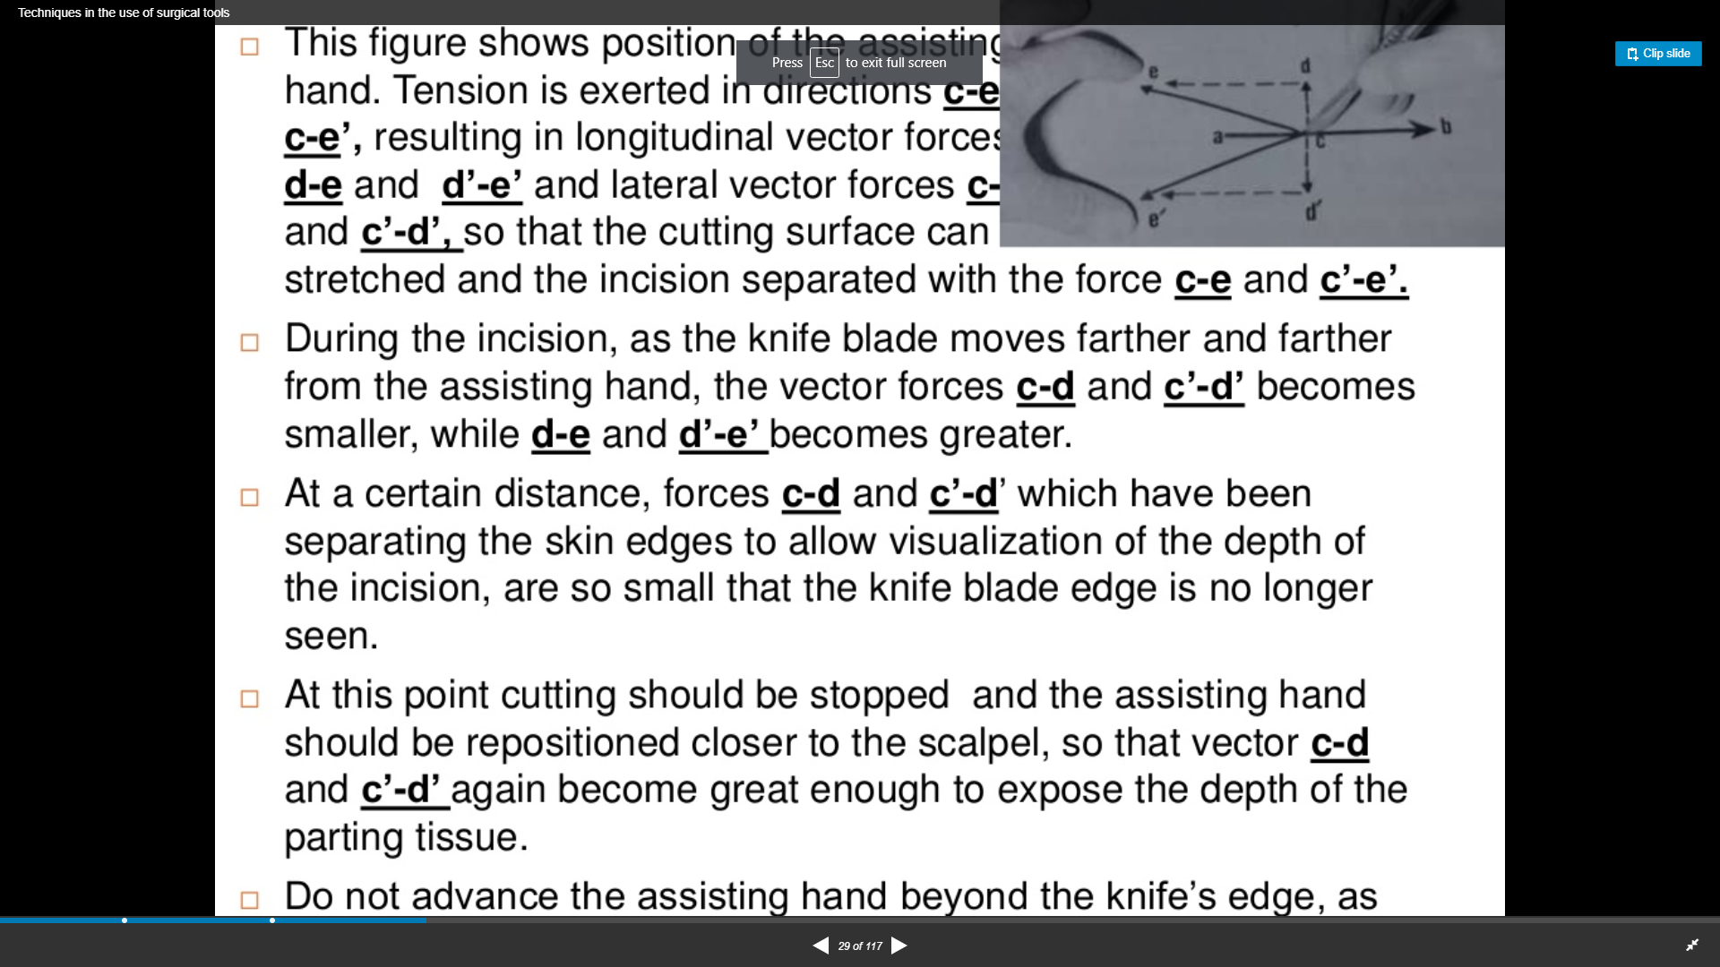

When making incision the knife should move from further from the assisting hand .this makes the vector c-d and c’-d’ becomes smaller and d-e,d’-e’ becomes smaller.

When making the incision, forces separating the skin edges for easier visualization into the incision at c-d and c’-d’ is so small that the blade is no longer visible. This is a sign to stop cutting and reposition the assisting hand closer to the scalpel in order to for the forces at c-d and c’-d’ to be great enough to expose the tissue cutting (Khan ,2017)

**Backhand cutting technique**

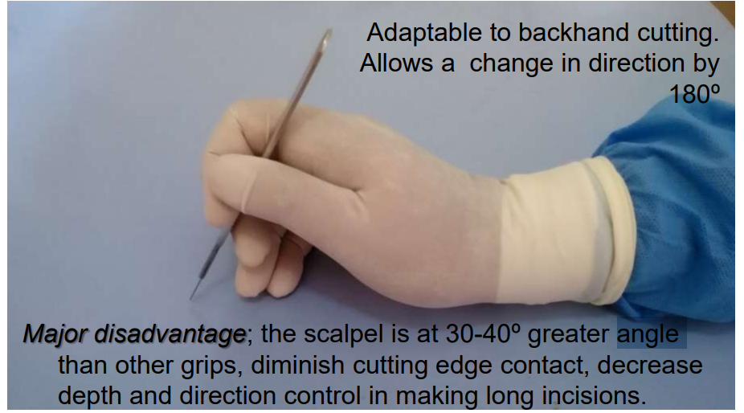

Figure (Dr. Khan 2017)

Backhand cutting was considered when choosing a technique due to the fact that it allows a change in direction of approximately 180 degrees when making an incision but due to its several major disadvantages it was taken out. These disadvantages include the fact that the blade (as shown in the figure above fig 13) has a reduced cutting edge contact area. Another disadvantage is the decrease in the depth and direction when making long incisions. This is all due to the grip is 30 degrees greater than a regular grip. (Khan, 2017)

**Four other methods of making scalpel incision**

This includes press cutting, slide cutting, sawing, and scraping

Press cutting

This type of incision controls the length and direction of the wound. This is done by applying pressure in the same direction as the blade. The only flaw is that the depth is not controlled. (Ausaf Khan ,2017)

Slide cutting

The surgeon applies pressure at a right angle to the direction the blade moves. The blade simply slides across the tissue. This increases the precision of deep cuts. (Khan ,2017)

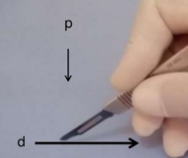

Figure “The motion is at a right angle to the scalpel pressure”. (Khan ,2017)

Sawing

The surgeon moves the blade back and forth in a push-pull type movement. This creates deep single cuts. This creates deeper cuts without having to remove the blade. (Khan ,2017) .This reduces bleeding

Scrapping

The scalpel is moved perpendicular to the edge of the blade and the direction of pressure (Khan ,2017)

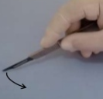

**3.Other instruments methods considered**

Dunhill artery forceps

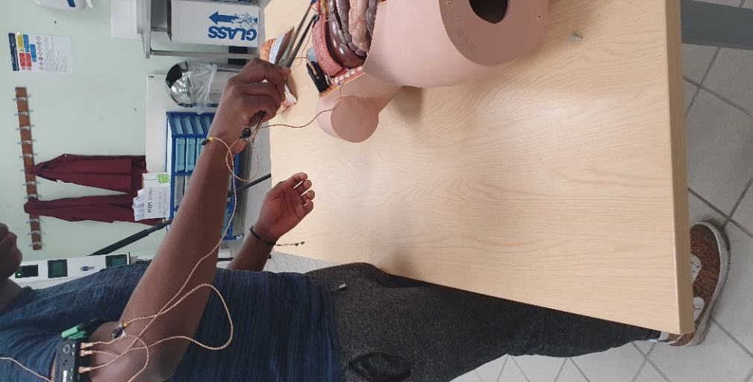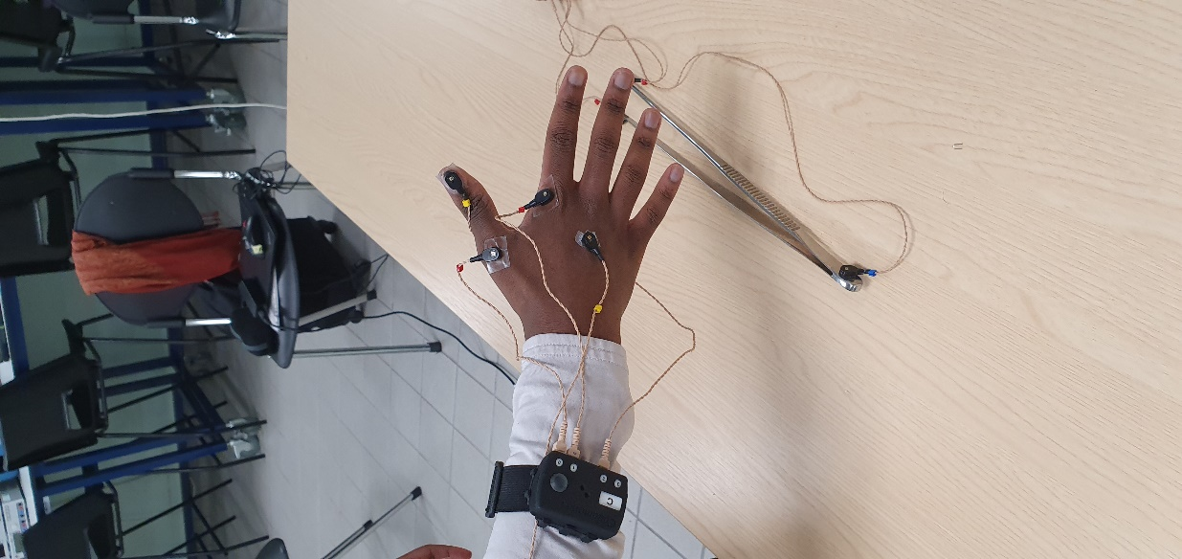

Figure Markers are also placed on the arm and the hand to measure the movement angles. The goal is to reduce shaking for a steady arm.

Needle holder

The needle is held at the tip of the jaws. This is about two-thirds of the way along needle’s circumference. Once comfortable the ratchet is locked to secure the position. The needle is held at a 90° to the tissue's surface. This is done in order to get the best hold of the tissues being sutured. Markers are placed on the finger holding it. (B. Braun Surgical S.A., n.d.)

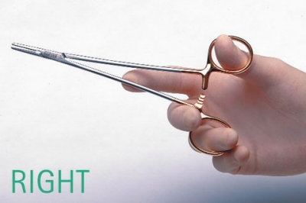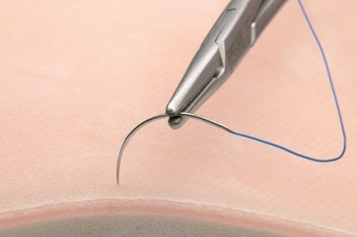

Figure The needle and position of markers (B. Braun Surgical S.A., n.d.)

Langenbeck retractor

Langenbeck retractor designed by, Bernhard is used to retract soft tissues and wound edges in order to visualize deeper structures. The long teardrop handle has a central fenestration for enhanced grips. The long neck provides additional reach without concealing the surgical view,

**Section C**

The 5 instruments/tools trials

NOTE: This sample of the large data set. If more information is needed please refer to logbook data set section

Method 1

Arm angles

trial 1



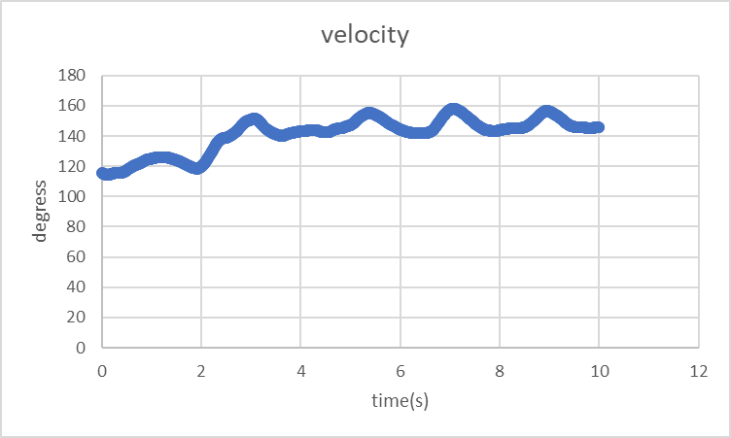

Angular velocity = ((final angle) - (initial angle)) / time = change in position/time

The graph above demonstrates how increasing velocity (gradient value) at certain times caused a greater change in displacement (change in degrees). This can be seen in from the 2 to 3 seconds where they are a steep gradient of 150-120=130. The point of this experiment was to reduce this change and maintain a fixed position. This means the velocity will be reduced in the second trial

Trial 2



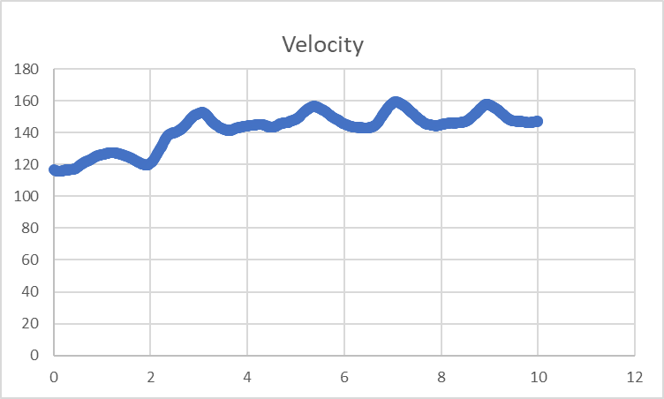

Trial 3



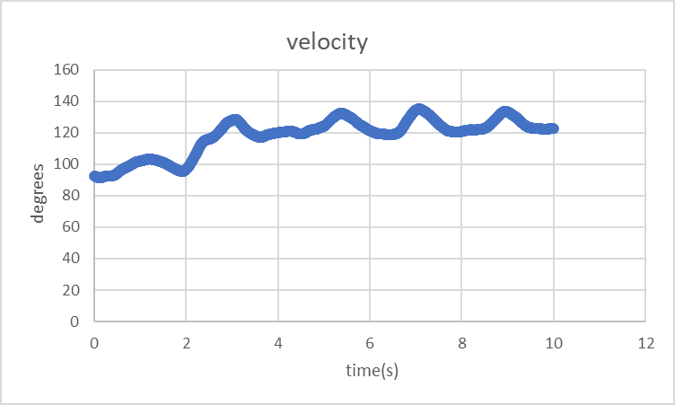

Scalpel angles

Trial 1



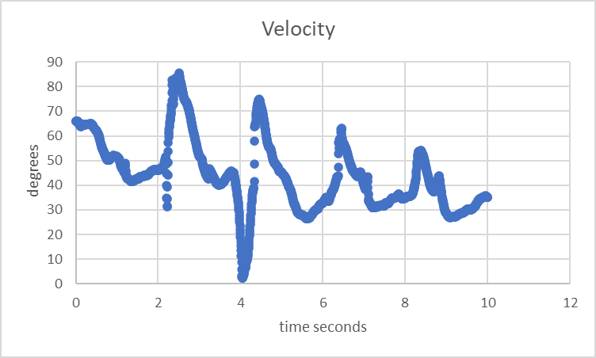

Trial 2



Trial 3



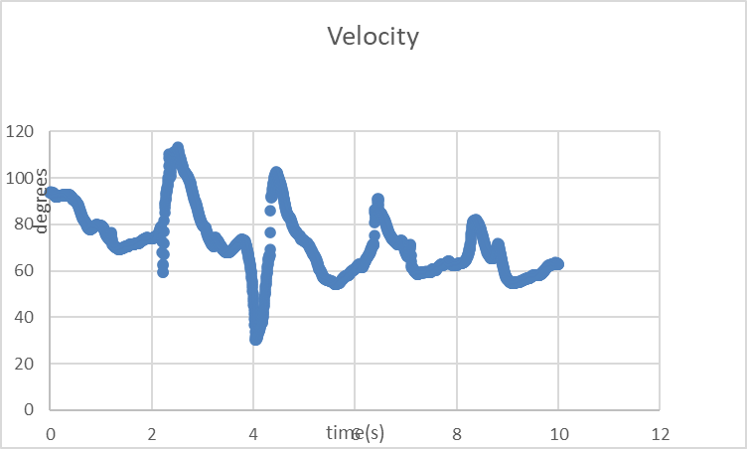

Method 2

Arm angles

Trial 1



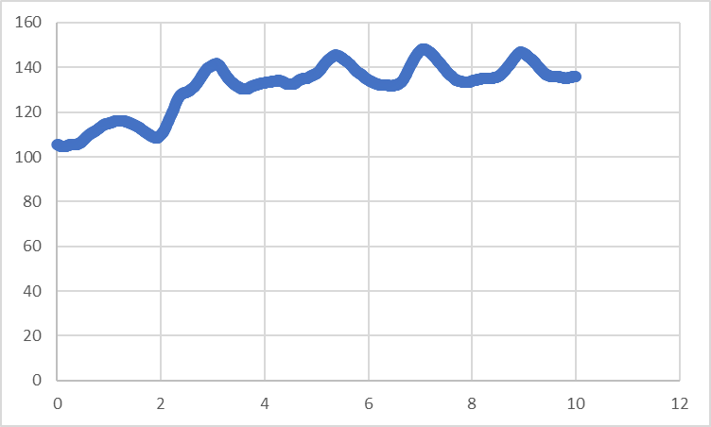

Trial 2



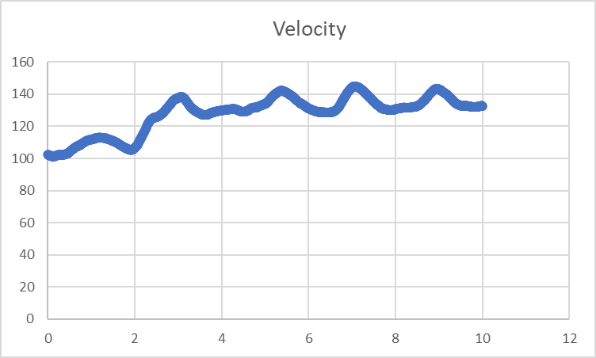

Trial 3



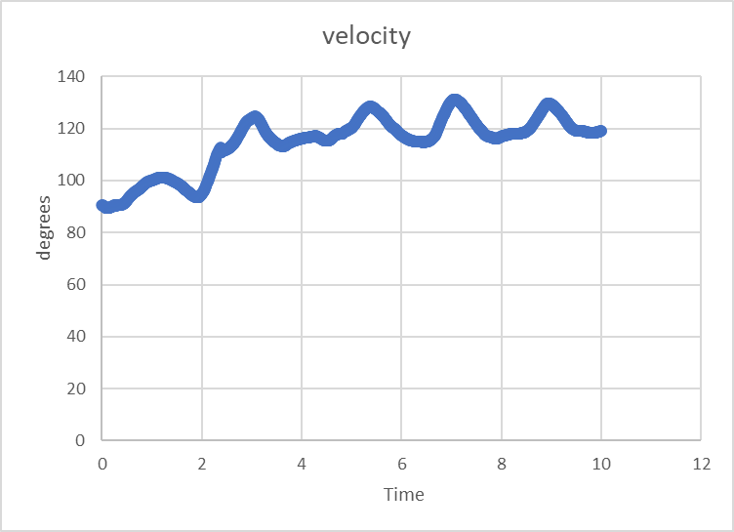

Scalpel angles

Trial 1



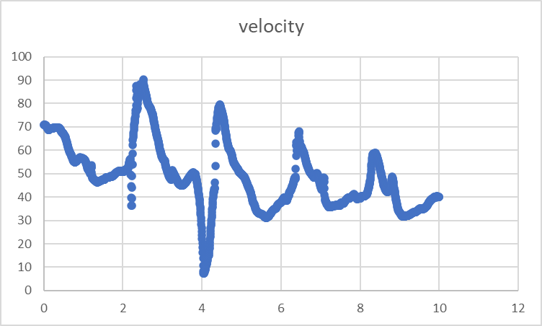

Trial 2



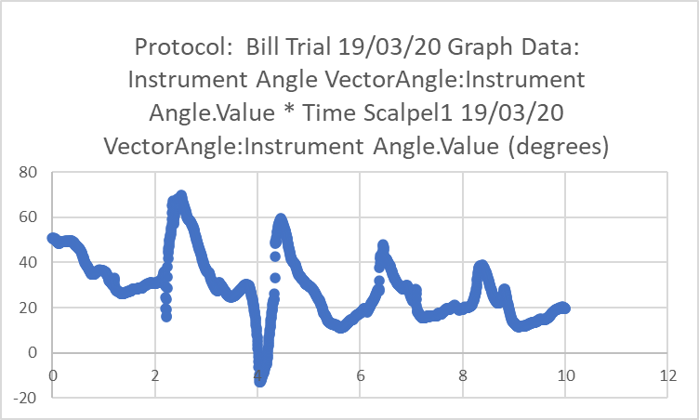

Trial 3



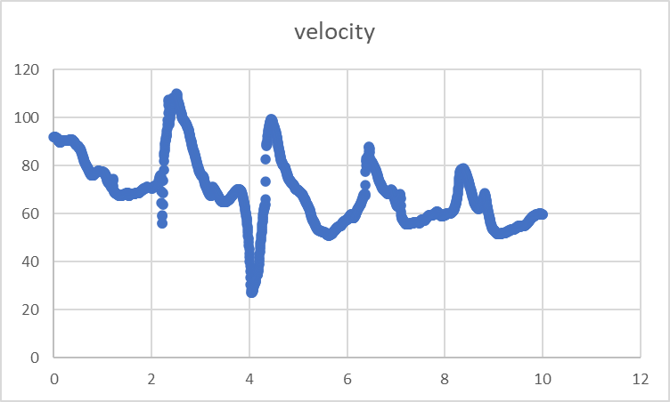

Method 3

Arm angles

Trial 1



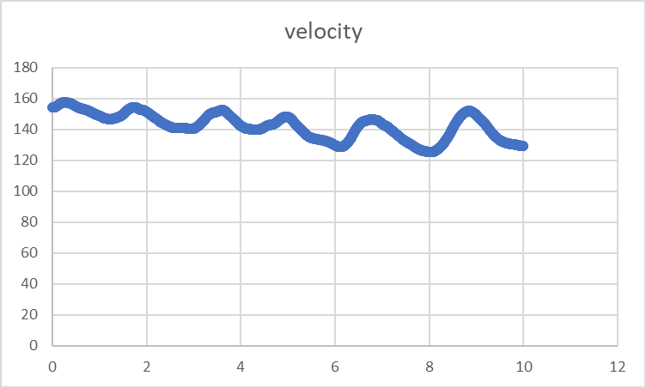

Trial 2



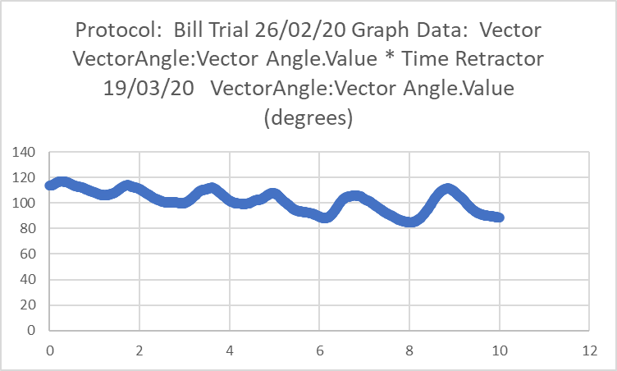

Trial 3



Scissors angles

Trial 1



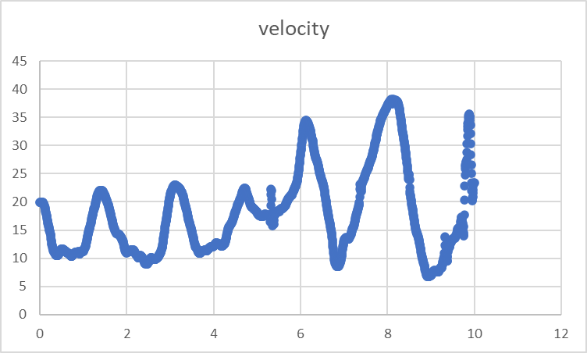

Trial 2



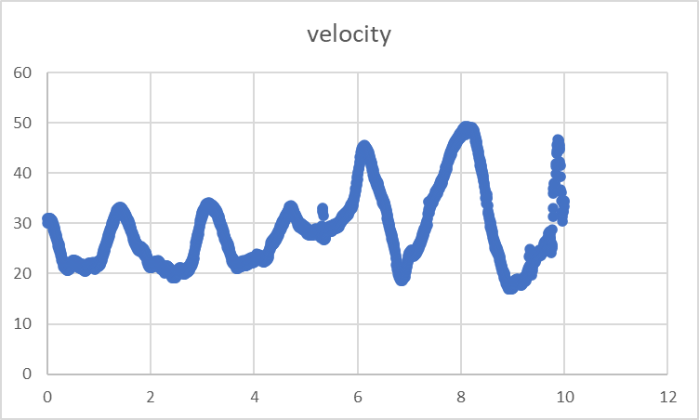

Trial 3



Other instruments data collected

Forceps



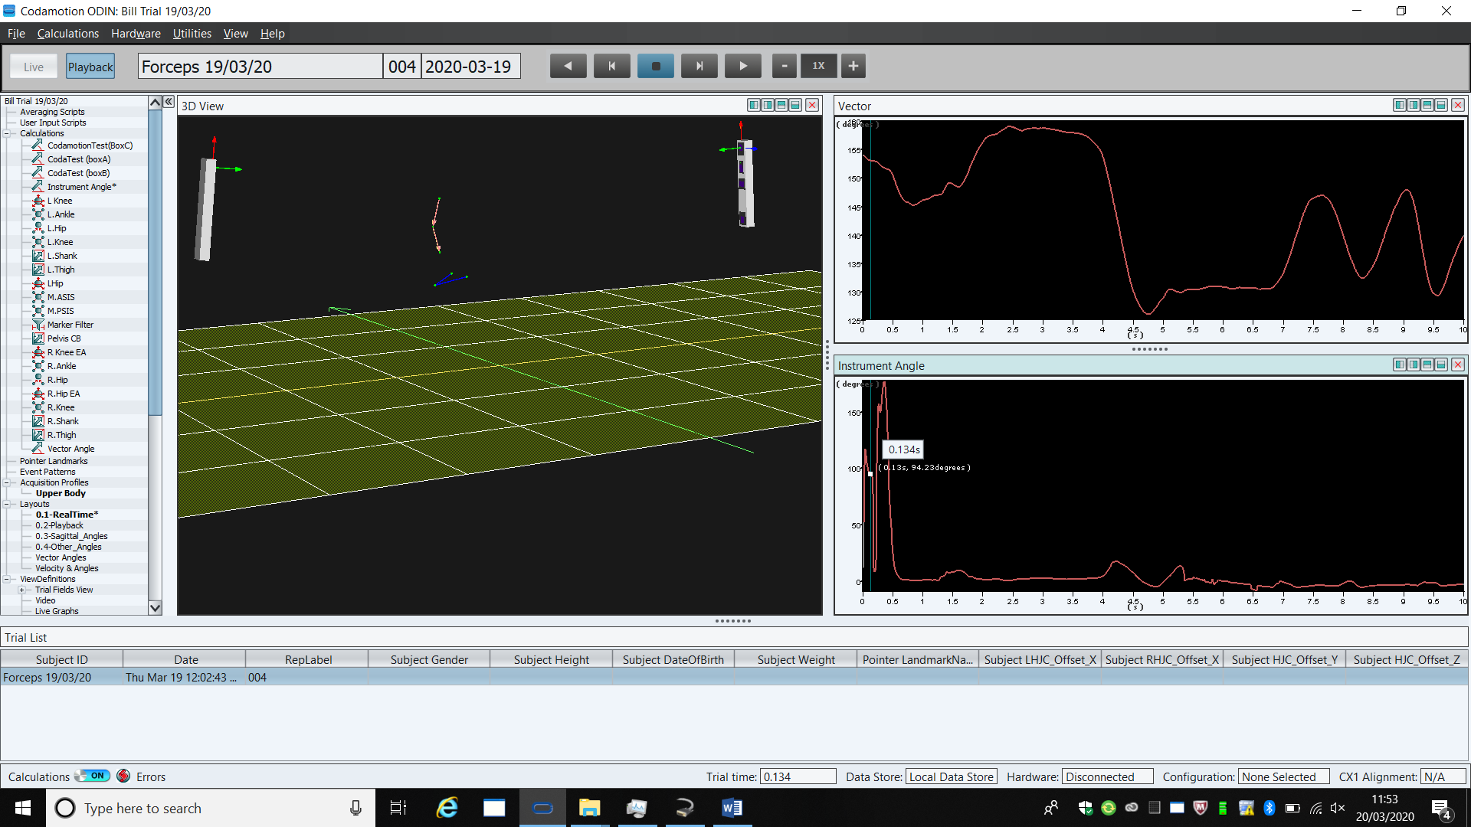

Arm angles



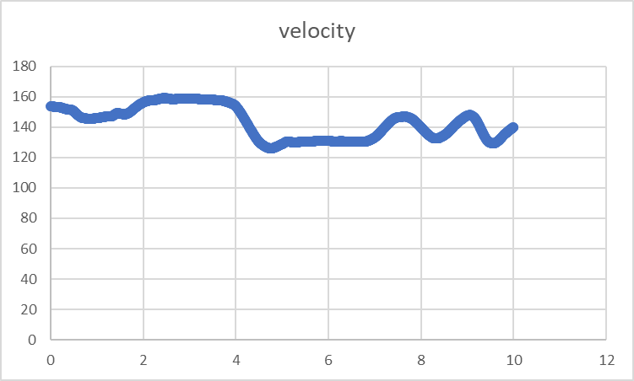

Forceps angles



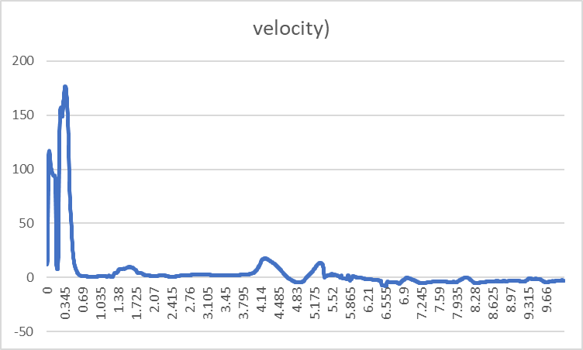

Clamps

Arm angles



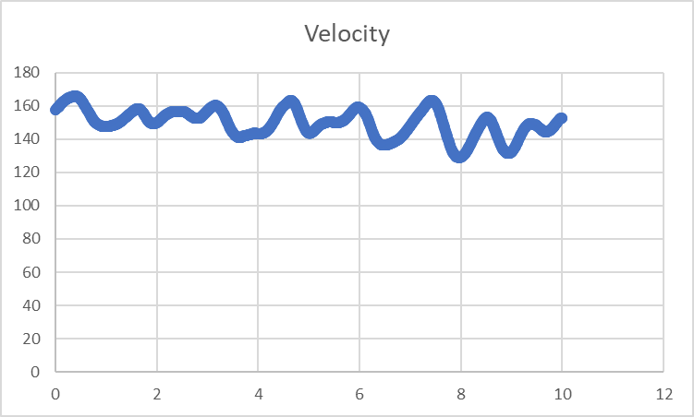

clamps angles



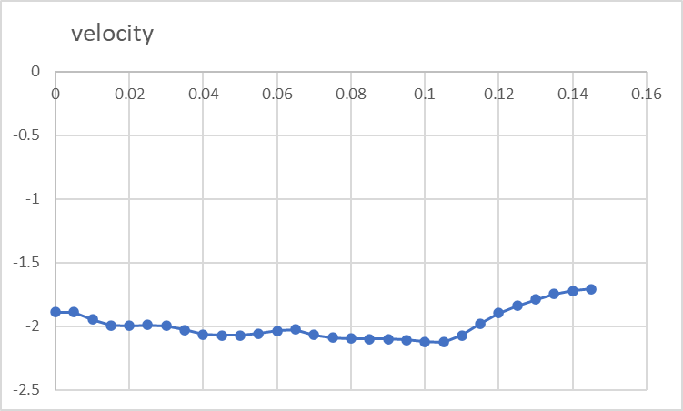

**section D**

1.Discussion

In detail, the first procedure first trial showed how poorly the participant held the correct position in the first trial. The third trial showed a huge improvement in results. This improvement was a result of the participant becoming more accustomed to the procedure and maintained a constant velocity. The repeat also helped develop muscle memory (Papanikolaou, it. el,2019).

The second and third showed a similar pattern

**2.**

Information on how the tools/instruments and arm should be positioned during procedures was collected and analysed meticulously creating the opportunity to try and replicate it